

Autonomous, Shamshabad-501218.

**VARDHAMAN COLLEGE OF ENGINEERING**

**DEPARTMENT OF COMPUTER SCIENCE AND TECHNOLOGY**

**OPEN SOURCE TECHNOLOGIES**

**LAB RECORD**

**VII Semester**

**A3606**

**Name:** Neerukonda Puneeth

**Roll No.:** 17881A0526

**Section:** A



VARDHAMAN COLLEGE OF ENGINEERING

Autonomous, Shamshabad-501218.

**EXPERIMENT- 01**

**a.Performing basic DML , DDL commands using Mysql.**

MariaDB [(none)]> show databases;

+--------------------+

| Database |

+--------------------+

| college |

| information_schema|

| mysql |

| performance_schema |

| phpMyAdmin |

| test |

+--------------------+

6 rows in set (0.002 sec)

MariaDB [(none)]> use college;

MariaDB [college]> create table student(

-> name varchar(20),

->id int,

->place varchar(20)

-> );

Query OK, 0 rows affected (0.174 sec)

MariaDB [college]> insert into student(name,id,place)values("pallavi",1,"hyderabad");

Query OK, 1 row affected (0.162 sec)

MariaDB [college]> insert into student(name,id,place)values("kaveri",2,"bangalore");

Query OK, 1 row affected (0.057 sec)

MariaDB [college]> insert into student(name,id,place)values("krishna",3,"chennai");

Query OK, 1 row affected (0.026 sec)

MariaDB [college]> insert into student(name,id,place)values("ram",4,"mumbai");

Query OK, 1 row affected (0.084 sec)

MariaDB [college]> select * from student;

+---------+------+-----------+

| name | id | place |

+---------+------+-----------+

| pallavi | 1 | hyderabad |

| kaveri | 2 | bangalore |

| krishna | 3 | chennai |

| ram | 4 | mumbai |

+---------+------+-----------+

4 rows in set (0.000 sec)



VARDHAMAN COLLEGE OF ENGINEERING

Autonomous, Shamshabad-501218.

MariaDB [college]> select * from student;

+---------+------+-----------+

| name | id | place |

+---------+------+-----------+

| pallavi | 1 | hyderabad |

| kaveri | 2 | bangalore |

| krishna | 3 | chennai |

| ram | 4 | mumbai |

+---------+------+-----------+

4 rows in set (0.000 sec)

MariaDB [college]> alter table student add course varchar(5);

Query OK, 0 rows affected (0.215 sec)

Records: 0 Duplicates: 0 Warnings: 0

MariaDB [college]> select * from student;

+---------+------+-----------+-------------+

| name | id | place | course |

+---------+------+-----------+-------------+

| pallavi | 1 | hyderabad | NULL |

| kaveri | 2 | bangalore | NULL |

| araya | 3 | chennai | NULL |

+---------+------+-----------+-------------+

3 rows in set (0.001 sec)

MariaDB [college]> drop table student;

Query OK, 0 rows affected (0.237 sec)

MariaDB [college]> select * from student;

ERROR 1146 (42S02): Table 'college.student' doesn't exist

1b)

i) MariaDB [college]> create table student(

-> id int,

-> name varchar(20),

-> address varchar(20),

-> degree varchar(20),

-> result float(5,2),

-> constraint student primary key(id)

-> );

Query OK, 0 rows affected (0.247 sec)

MariaDB [college]> create table module(

-> code int,

-> title varchar(20),



VARDHAMAN COLLEGE OF ENGINEERING

Autonomous, Shamshabad-501218.

-> crdval int,

-> mleades varchar(20),

-> teastff varchar(20),

-> depyr int,

-> constraint module primary key(code)

-> );

Query OK, 0 rows affected (0.335 sec)

MariaDB [college]> create table lectures(

-> id int,

-> name varchar(20),

-> mteach varchar(20),

-> dept varchar(20),

-> constraint lectures primary key(id)

-> );

Query OK, 0 rows affected (0.246 sec)

MariaDB [college]> create table college1(

-> ccode int,

-> name varchar(20),

-> loc varchar(20),

-> seat_dis int,

-> st_id int,

-> m_id int,

-> l_id int,

-> constraint primary key(ccode),

-> constraint cs_fk foreign key(st_id) references student(id),

-> constraint cm_fk foreign key(m_id) references module(code),

-> constraint cl_fk foreign key(l_id) references lectures(id)

-> );

ii)MariaDB [college]> insert into student values(1,'sai','hyd','Msc',9.3);

Query OK, 1 row affected (0.077 sec)

MariaDB [college]> insert into student values(2,'kavya','hyd','Bahons',8.5);

Query OK, 1 row affected (0.054 sec)

MariaDB [college]> select * from student;

+----+-------+------+--------+----------+

| id | name | addr | degree | crdscore |

+----+-------+------+--------+----------+

| 1 | sai | hyd | Msc | 9.3 |

| 2 | kavya | hyd | Bahons | 8.5 |

+----+-------+------+--------+----------+

2 rows in set (0.000 sec)



VARDHAMAN COLLEGE OF ENGINEERING

Autonomous, Shamshabad-501218.

MariaDB [college]> insert into module values(10,'Bahons',3,'A','kavya','commerece','cse',2);

Query OK, 1 row affected (0.058 sec)

MariaDB [college]> insert into module values(11,'Msc',4,'A','barbi','basicreg','cse',3);

Query OK, 1 row affected (0.069 sec)

MariaDB [college]> insert into module values(12,'Msc',4,'A','raju','basicreg','cse',4);

Query OK, 1 row affected (0.075 sec)

MariaDB [college]> insert into module values(13,'english',4,'B','pushpa','english','h&s',1);

Query OK, 1 row affected (0.022 sec)

MariaDB [college]> select * from module;

+------+---------+--------+---------+---------+-----------+------+-------+

| code | title | crdval | mleades | teastff | preq | dept | depyr |

+------+---------+--------+---------+---------+-----------+------+-------+

| 10 | Bahons | 3 | A | kavya | commerece | cse | 2 |

| 11 | Msc | 4 | A | barbi | basicreg | cse | 3 |

| 12 | Msc | 4 | A | raju | basicreg | cse | 4 |

| 13 | english | 4 | B | pushpa | english | h&s | 1 |

+------+---------+--------+---------+---------+-----------+------+-------+

4 rows in set (0.001 sec)

MariaDB [college]> insert into lectures values(1,'rohit','stats','statistics');

Query OK, 1 row affected (0.078 sec)

MariaDB [college]> insert into lectures values(2,'kiran','maths','h&s');

Query OK, 1 row affected (0.067 sec)

MariaDB [college]> insert into lectures values(3,'abhi','graphs','statistics');

Query OK, 1 row affected (0.026 sec)

MariaDB [college]> insert into lectures values(4,'ravi','maths','h&s');

Query OK, 1 row affected (0.064 sec)

MariaDB [college]> insert into lectures values(5,'kiran','Msc','cse');

Query OK, 1 row affected (0.136 sec)

MariaDB [college]> insert into lectures values(6,'barbi','Msc','cse');

Query OK, 1 row affected (0.073 sec)

MariaDB [college]> insert into lectures values(7,'raju','Msc','cse');

Query OK, 1 row affected (0.048 sec)

MariaDB [college]> insert into lectures values(8,'pushpa','english','h&s');

Query OK, 1 row affected (0.028 sec)



VARDHAMAN COLLEGE OF ENGINEERING

Autonomous, Shamshabad-501218.

MariaDB [college]> insert into lectures values(9,'arun','Msc','cse');

Query OK, 1 row affected (0.051 sec)

MariaDB [college]> insert into lectures values(10,'arjun','english','h&s');

Query OK, 1 row affected (0.067 sec)

MariaDB [college]> select * from lectures;

+----+--------+---------+------------+

| id | name | mteach | dept |

+----+--------+---------+------------+

| 1 | rohit | stats | statistics |

| 2 | kiran | maths | h&s |

| 3 | abhi | graphs | statistics |

| 4 | ravi | maths | h&s |

| 5 | kiran | Msc | cse |

| 6 | barbi | Msc | cse |

| 7 | raju | Msc | cse |

| 8 | pushpa | english | h&s |

| 9 | arun | Msc | cse |

| 10 | arjun | english | h&s |

+----+--------+---------+------------+

10 rows in set (0.001 sec)

MariaDB [college]> insert into college1 values(102,'vce','hyd',400,2,10,5);

Query OK, 1 row affected (0.061 sec)

MariaDB [college]> insert into college1 values(100,'vmeg','hyd',300,1,11,6);

Query OK, 1 row affected (0.048 sec)

MariaDB [college]> select * from college1;

+-------+------+------+----------+-------+------+------+

| ccode | name | loc | seat_dis | st_id | m_id | l_id |

+-------+------+------+----------+-------+------+------+

| 100 | vmeg | hyd | 300 | 1 | 11 | 6 |

| 102 | vce | hyd | 400 | 2 | 10 | 5 |

+-------+------+------+----------+-------+------+------+

2 rows in set (0.000 sec)

iii)MariaDB [college]> select name from student where degree='Msc';

+------+

| name |

+------+

| sai |

+------+

1 row in set (0.001 sec)



VARDHAMAN COLLEGE OF ENGINEERING

Autonomous, Shamshabad-501218.

v)MariaDB [college]> select name from lectures where name not in (select distinct(mleades) from module);

+--------+

| name |

+--------+

| rohit |

| kiran |

| abhi |

| ravi |

| kiran |

| barbi |

| raju |

| pushpa |

| arun |

| arjun |

vi)MariaDB [college]> select dept from module where title='english';

+------+

| dept |

+------+

| h&s |

+------+

1 row in set (0.000 sec)

vii))MariaDB [college]> select dept,preq from module order by dept;

+------+-----------+

| dept | preq |

+------+-----------+

| cse | commerece |

| cse | basicreg |

| cse | basicreg |

| h&s | english |

+------+-----------+

4 rows in set (0.001 sec)

viii)MariaDB [college]> select id,name from lectures where mteach='maths';

+----+-------+

| id | name |

+----+-------+

| 2 | kiran |

| 4 | ravi |

+----+-------+

2 rows in set (0.000 sec)



VARDHAMAN COLLEGE OF ENGINEERING

Autonomous, Shamshabad-501218.

xi)MariaDB [college]> select title,count(depyr) from module group by title;

+---------+--------------+

title | count(depyr) |

+---------+--------------+

| Bahons | 1 |

| english | 1 |

| Msc | 2 |

+---------+--------------+

3 rows in set (0.001 sec)

x)MariaDB [college]> select id,name from lectures where dept='statistics';

+----+-------+

| id | name |

+----+-------+

| 1 | rohit |

| 3 | abhi |

+----+-------+

2 rows in set (0.000 sec)



VARDHAMAN COLLEGE OF ENGINEERING

Autonomous, Shamshabad-501218.

**EXPERIMENT-02**

i)MariaDB [employee]> select * from emp;

+-------+--------+-----------+------+------------+------+------+-------+

| empno | ename | job | mgr | hiredate | sal | comm | depno |

+-------+--------+-----------+------+------------+------+------+-------+

| 101 | smith | clerk | 7902 | 1980-12-17 | 800 | 0 | 20 |

| 102 | allen | salesman | 7698 | 1981-02-20 | 1600 | 300 | 30 |

| 103 | ward | salesman | 7698 | 1981-02-22 | 1250 | 500 | 30 |

| 104 | johnes | manager | 7839 | 1981-04-02 | 2975 | 0 | 20 |

| 105 | martin | salesman | 7698 | 1981-09-28 | 1250 | 1400 | 30 |

| 106 | clark | manager | 7839 | 1981-06-09 | 2450 | 0 | 10 |

| 107 | scott | analyst | 7566 | 1982-12-09 | 3000 | 0 | 20 |

| 108 | king | president | 0 | 1981-11-17 | 5000 | 0 | 10 |

| 109 | turner | salesman | 7698 | 1981-09-08 | 1500 | 0 | 30 |

| 110 | adams | clerk | 7788 | 1981-09-08 | 1100 | 0 | 20 |

| 111 | ford | analyst | 7566 | 1983-01-12 | 3000 | 0 | 20 |

| 112 | miller | clerk | 7782 | 1982-01-23 | 1300 | 0 | 10 |

+-------+--------+-----------+------+------------+------+------+-------+

12 rows in set (0.001 sec)

ii)MariaDB [employee]> select * from dept;

+-------+------------+---------+

| depno | depname | loca |

+-------+------------+---------+

| 10 | accounting | newyork |

| 20 | research | dallas |

| 30 | sales | chicago |

| 40 | operations | boston |

+-------+------------+---------+

4 rows in set (0.000 sec)

iii)MariaDB [employee]> update emp set ename='adam' where ename='adams';

Query OK, 1 row affected (0.069 sec)

Rows matched: 1 Changed: 1 Warnings: 0

MariaDB [employee]> select * from emp;

+-------+--------+-----------+------+------------+------+------+-------+

| empno | ename | job | mgr | hiredate | sal | comm | depno |

+-------+--------+-----------+------+------------+------+------+-------+

| 101 | smith | clerk | 7902 | 1980-12-17 | 800 | 0 | 20 |

| 102 | allen | salesman | 7698 | 1981-02-20 | 1600 | 300 | 30 |

| 103 | ward | salesman | 7698 | 1981-02-22 | 1250 | 500 | 30 |

| 104 | johnes | manager | 7839 | 1981-04-02 | 2975 | 0 | 20 |

| 105 | martin | salesman | 7698 | 1981-09-28 | 1250 | 1400 | 30 |

| 106 | clark | manager | 7839 | 1981-06-09 | 2450 | 0 | 10 |



VARDHAMAN COLLEGE OF ENGINEERING

Autonomous, Shamshabad-501218.

| 107 | scott | analyst | 7566 | 1982-12-09 | 3000 | 0 | 20 |

| 108 | king | president | 0 | 1981-11-17 | 5000 | 0 | 10 |

| 109 | turner | salesman | 7698 | 1981-09-08 | 1500 | 0 | 30 |

| 110 | adam | clerk | 7788 | 1981-09-08 | 1100 | 0 | 20 |

| 111 | ford | analyst | 7566 | 1983-01-12 | 3000 | 0 | 20 |

| 112 | miller | clerk | 7782 | 1982-01-23 | 1300 | 0 | 10 |

+-------+--------+-----------+------+------------+------+------+-------+

12 rows in set (0.000 sec)

iv)MariaDB [employee]> update emp set sal=2000,comm=500 where empno=109;

Query OK, 1 row affected (0.070 sec)

Rows matched: 1 Changed: 1 Warnings: 0

MariaDB [employee]> select * from emp;

+-------+--------+-----------+------+------------+------+------+-------+

| empno | ename | job | mgr | hiredate | sal | comm | depno |

+-------+--------+-----------+------+------------+------+------+-------+

| 101 | smith | clerk | 7902 | 1980-12-17 | 800 | 0 | 20 |

| 102 | allen | salesman | 7698 | 1981-02-20 | 1600 | 300 | 30 |

| 103 | ward | salesman | 7698 | 1981-02-22 | 1250 | 500 | 30 |

| 104 | johnes | manager | 7839 | 1981-04-02 | 2975 | 0 | 20 |

| 105 | martin | salesman | 7698 | 1981-09-28 | 1250 | 1400 | 30 |

| 106 | clark | manager | 7839 | 1981-06-09 | 2450 | 0 | 10 |

| 107 | scott | analyst | 7566 | 1982-12-09 | 3000 | 0 | 20 |

| 108 | king | president | 0 | 1981-11-17 | 5000 | 0 | 10 |

| 109 | turner | salesman | 7698 | 1981-09-08 | 2000 | 500 | 30 |

| 110 | adam | clerk | 7788 | 1981-09-08 | 1100 | 0 | 20 |

| 111 | ford | analyst | 7566 | 1983-01-12 | 3000 | 0 | 20 |

| 112 | miller | clerk | 7782 | 1982-01-23 | 1300 | 0 | 10 |

+-------+--------+-----------+------+------------+------+------+-------+

12 rows in set (0.000 sec)

v)MariaDB [employee]> select depno,depname from dept where depno>10 and loca='newyork';

Empty set (0.000 sec)

vi)MariaDB [employee]> select * from emp where depno=10 and job='clerk';

+-------+--------+-------+------+------------+------+------+-------+

| empno | ename | job | mgr | hiredate | sal | comm | depno |

+-------+--------+-------+------+------------+------+------+-------+

| 101 | smith | clerk | 7902 | 1980-12-17 | 800 | 0 | 20 |

| 110 | adam | clerk | 7788 | 1981-09-08 | 1100 | 0 | 20 |

| 112 | miller | clerk | 7782 | 1982-01-23 | 1300 | 0 | 10 |

+-------+--------+-------+------+------------+------+------+-------+

3 rows in set (0.001 sec)



VARDHAMAN COLLEGE OF ENGINEERING

Autonomous, Shamshabad-501218.

vii)MariaDB [employee]> select count(*),depno from emp where job='clerk' group by depno having depno=10;

+----------+-------+

| count(*) | depno |

+----------+-------+

| 1 | 10 |

+----------+-------+

1 row in set (0.001 sec)

viii)MariaDB [employee]> select avg(sal) from emp;

+-----------+

| avg(sal) |

+-----------+

| 2143.7500 |

+-----------+

1 row in set (0.000 sec)

ix)MariaDB [employee]> select * from emp where sal=(select avg(sal)from emp);

Empty set (0.000 sec)

x)MariaDB [employee]> select * from emp where sal=(select min(sal)from emp);

+-------+-------+-------+------+------------+------+------+-------+

| empno | ename | job | mgr | hiredate | sal | comm | depno |

+-------+-------+-------+------+------------+------+------+-------+

| 101 | smith | clerk | 7902 | 1980-12-17 | 800 | 0 | 20 |

+-------+-------+-------+------+------------+------+------+-------+

1 row in set (0.004 sec)

xi)MariaDB [employee]> select e.ename from emp e where e.ename='a%n';

Empty set (0.000 sec)

xii)MariaDB [employee]> select * from emp where sal>1500 order by depno;

+-------+--------+-----------+------+------------+------+------+-------+

| empno | ename | job | mgr | hiredate | sal | comm | depno |

+-------+--------+-----------+------+------------+------+------+-------+

| 106 | clark | manager | 7839 | 1981-06-09 | 2450 | 0 | 10 |

| 108 | king | president | 0 | 1981-11-17 | 5000 | 0 | 10 |

| 104 | johnes | manager | 7839 | 1981-04-02 | 2975 | 0 | 20 |

| 107 | scott | analyst | 7566 | 1982-12-09 | 3000 | 0 | 20 |

| 111 | ford | analyst | 7566 | 1983-01-12 | 3000 | 0 | 20 |

| 102 | allen | salesman | 7698 | 1981-02-20 | 1600 | 300 | 30 |

| 109 | turner | salesman | 7698 | 1981-09-08 | 2000 | 500 | 30 |

+-------+--------+-----------+------+------------+------+------+-------+

7 rows in set (0.001 sec)



VARDHAMAN COLLEGE OF ENGINEERING

Autonomous, Shamshabad-501218.

xiii)MariaDB [employee]> select d.depno,d.depname,min(e.sal) from dept d,emp e where d.depno=e.depno group by d.depno,d.depname;

+-------+------------+------------+

| depno | depname | min(e.sal) |

+-------+------------+------------+

| 10 | accounting | 1300 |

| 20 | research | 800 |

| 30 | sales | 1250 |

+-------+------------+------------+

3 rows in set (0.001 sec)

xiv)MariaDB [employee]> select e.ename,e.empno,d.depname,d.loca from emp e,dept d where

-> d.depno=e.depno;

+--------+-------+------------+---------+

| ename | empno | depname | loca |

+--------+-------+------------+---------+

| smith | 101 | research | dallas |

| allen | 102 | sales | chicago |

| ward | 103 | sales | chicago |

| johnes | 104 | research | dallas |

| martin | 105 | sales | chicago |

| clark | 106 | accounting | newyork |

| scott | 107 | research | dallas |

| king | 108 | accounting | newyork |

| turner | 109 | sales | chicago |

| adam | 110 | research | dallas |

| ford | 111 | research | dallas |

| miller | 112 | accounting | newyork |

+--------+-------+------------+---------+

12 rows in set (0.001 sec)

xv)MariaDB [employee]> select ename,empno,sal from emp where hiredate>'1997-02-01';

Empty set (0.001 sec)

MariaDB [employee]> select max(sal) from emp where sal<(select max(sal) from emp);

+----------+

| max(sal) |

+----------+

| 3000 |

+----------+

1 row in set (0.000 sec)

MariaDB [employee]> select ename from emp where mgr is null;

Empty set (0.001 sec)



VARDHAMAN COLLEGE OF ENGINEERING

Autonomous, Shamshabad-501218.

**EXPERIMENT-03**

**3a) Write a PHP program to validate form contents using regular expressions.**

<?php

$name=$email=$username=$password=$gender="";

$error_name=$error_email=$valid_name=$valid_email=$valid_password=$valid_username=$valid_gender="";

$error_password=$error_username=$error_gender="";

if($_POST)

{

$name = $_POST['name'];

$email = $_POST['email'];

$username = $_POST['username'];

$password = $_POST['password'];

$gender = $_POST['gender'];

if (preg_match('/^[A-Za-z0-9 ]{3,20}$/',$name)) // Full Name

{

$valid_name=$name;

}

else

{

$error_name="Enter valid Name.";

}

if (preg_match('/^[a-zA-Z0-9._-]+@[a-zA-Z0-9._-]+\.([a-zA-Z]{2,4})$/', $email)) // Email

{

$valid_email=$email;

}

else

{

$error_email="Enter valid Email.";

}

if (preg_match('/^[A-Za-z0-9_]{3,20}$/',$username)) // Usename min 2 char max 20 char

{

$valid_username=$username;

}

else

{

$error_username="Enter valid Username min 3 Chars.";

}

if (preg_match('/^[A-Za-z0-9!@#$%^&*()_]{6,20}$/',$password))

{

$valid_password=$password;

}

else



VARDHAMAN COLLEGE OF ENGINEERING

Autonomous, Shamshabad-501218.

{

$error_password="Enter valid Password min 6 Chars.";

}

if ($gender==0) // Gender

{

$error_gender="Select Gender";

}

else

{

$valid_gender=$gender;

}

if((strlen($valid_name)>0)&&(strlen($valid_email)>0)&&(strlen($valid_username)>0)&&(strlen($valid_password)>0) && $valid_gender>0 )

{

echo "validation Success";

}

else{

echo "error";

}

}

?>

<form method="post" action="" name="form">

Full name : <input type="text" name="name" value="<?php echo $valid_name; ?>" />

<?php echo $error_name; ?></br>

Email : <input type="text" name="email" value="<?php echo $valid_email; ?>" />

<?php echo $error_email; ?></br>

Username : <input type="text" name="username" value="<?php echo $valid_username; ?>"

/>

<?php echo $error_username; ?></br>

Password : <input type="password" name="password" value="<?php echo $valid_password;

?>" />

<?php echo $error_password; ?></br>

Gender : <select name="gender">

<option value="0">Gender</option>

<option value="1">Male</option>

<option value="2">Female</option> </select>

<?php echo $error_gender; ?> <br>

<input type="submit" value="Submit">

</form>

**Output:**

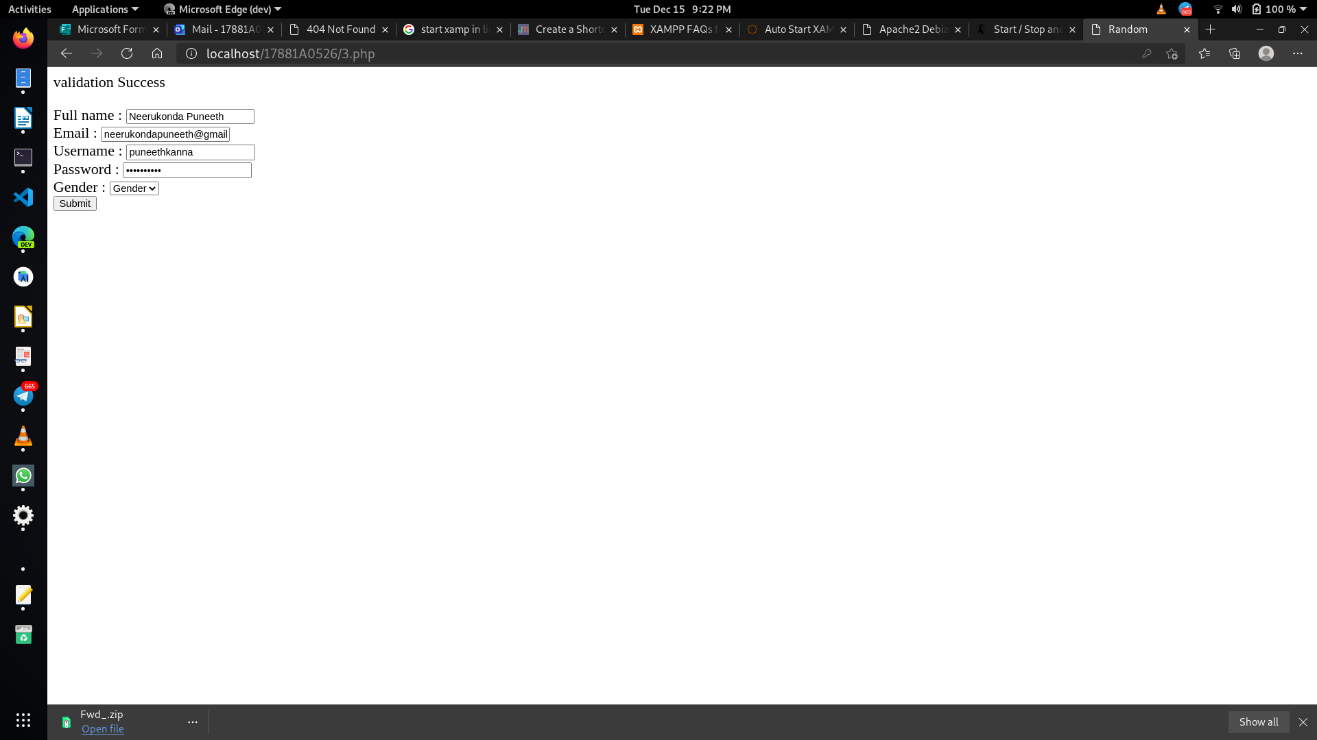



VARDHAMAN COLLEGE OF ENGINEERING

Autonomous, Shamshabad-501218.

**3b) Write a PHP program to merge the contents of two files and store into another file.**

<?php

$lines = file('Country.txt');

$lines2 = file('countryenglish.txt');

foreach ($lines as $key => $val) {

$lines[$key] = $val.$lines2[$key];

}

file_put_contents('countryenglish2.txt', implode("\n", $lines));

?>

**Output:**

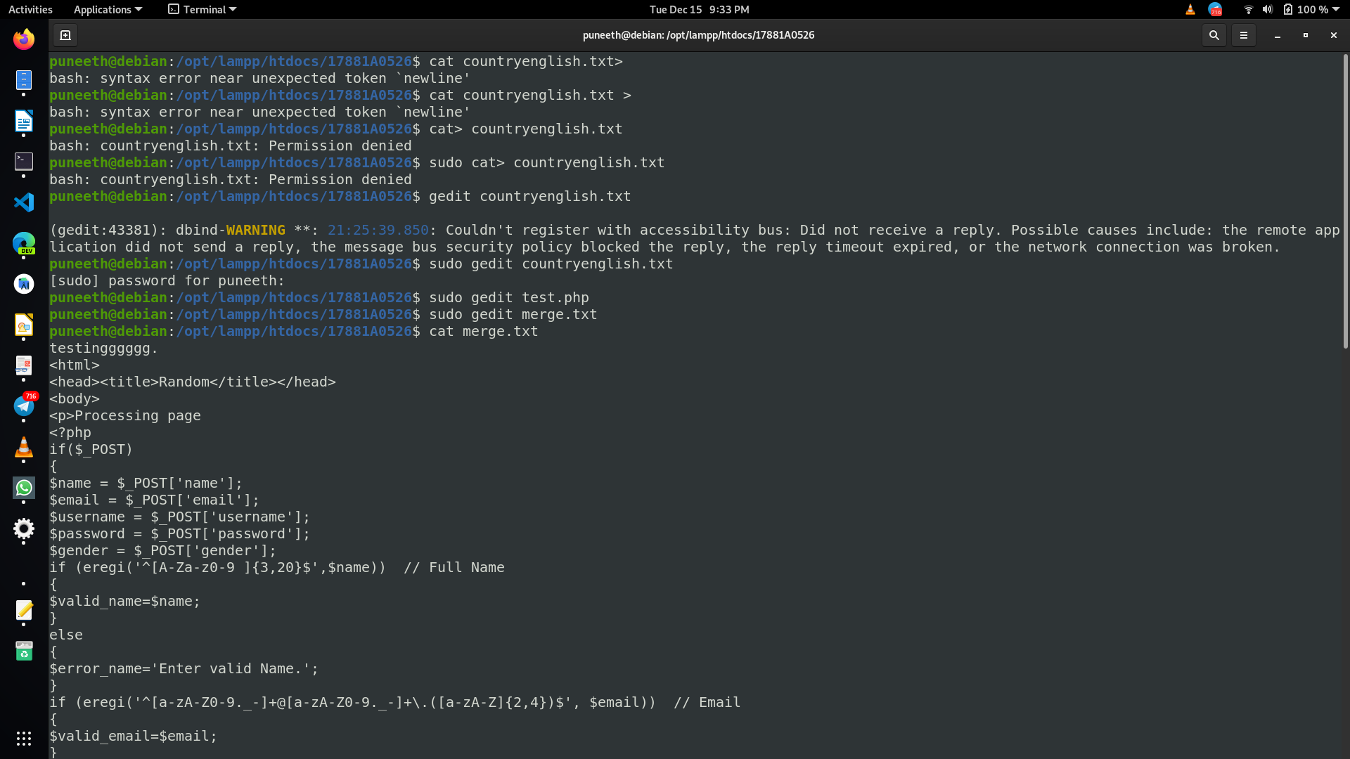



VARDHAMAN COLLEGE OF ENGINEERING

Autonomous, Shamshabad-501218.

**EXPERIMENT-04**

**4a)Write a PHP program to create a ZIP file using PHP.**

<?php

$zip = new ZipArchive;

if ($zip->open('test_new.zip', ZipArchive::CREATE) === TRUE)

{

$zip->addFile('countryenglish.txt');

$zip->addFile('valid.php');

$zip->addFile('2b.php');

$zip->close();

}

?>

**Output:**

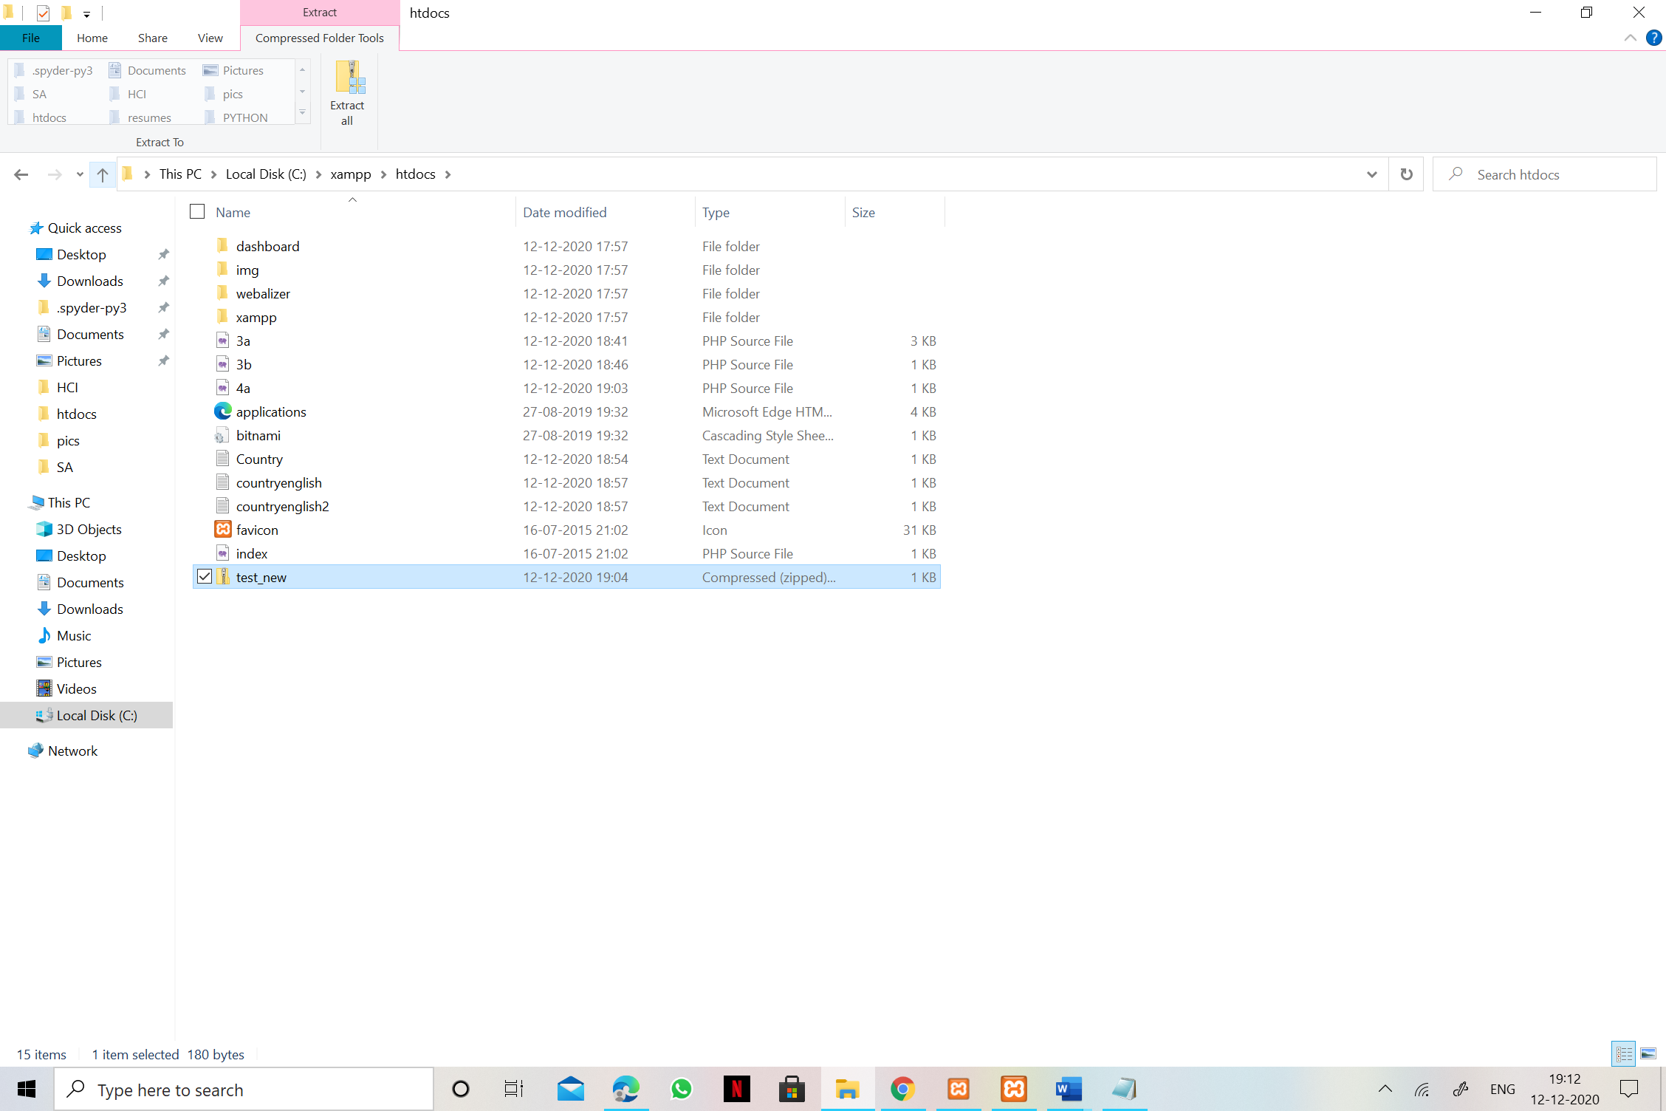



VARDHAMAN COLLEGE OF ENGINEERING

Autonomous, Shamshabad-501218.

**4b) Write a PHP program to validate IP address, Integer and E-mail using filters.**

<?php

$ip = "127.0.0.1";

if (!filter_var($ip, FILTER_VALIDATE_IP) === false) {

echo("$ip is a valid IP address");

} else {

echo("$ip is not a valid IP address");

}

?>

<br>

<?php

$email = "john.doe@example.com";

// Remove all illegal characters from email

$email = filter_var($email, FILTER_SANITIZE_EMAIL);

// Validate e-mail

if (!filter_var($email, FILTER_VALIDATE_EMAIL) === false) {

echo("$email is a valid email address");

} else {

echo("$email is not a valid email address");

}

?>

<br>

<?php

$int = 100;

if (!filter_var($int, FILTER_VALIDATE_INT) === false) {

echo("Integer is valid");

} else {

echo("Integer is not valid");

}

?>

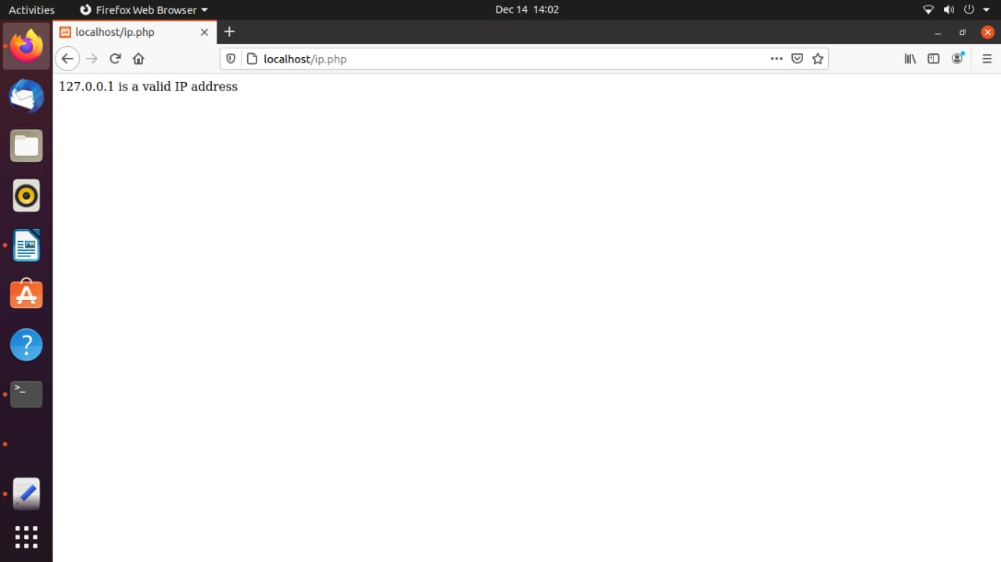**Output:**

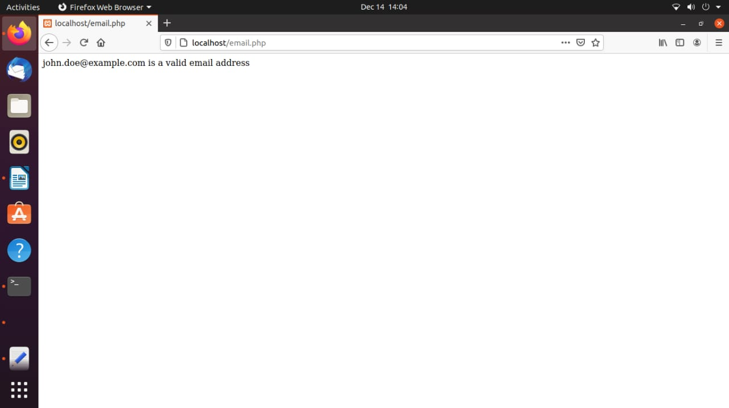

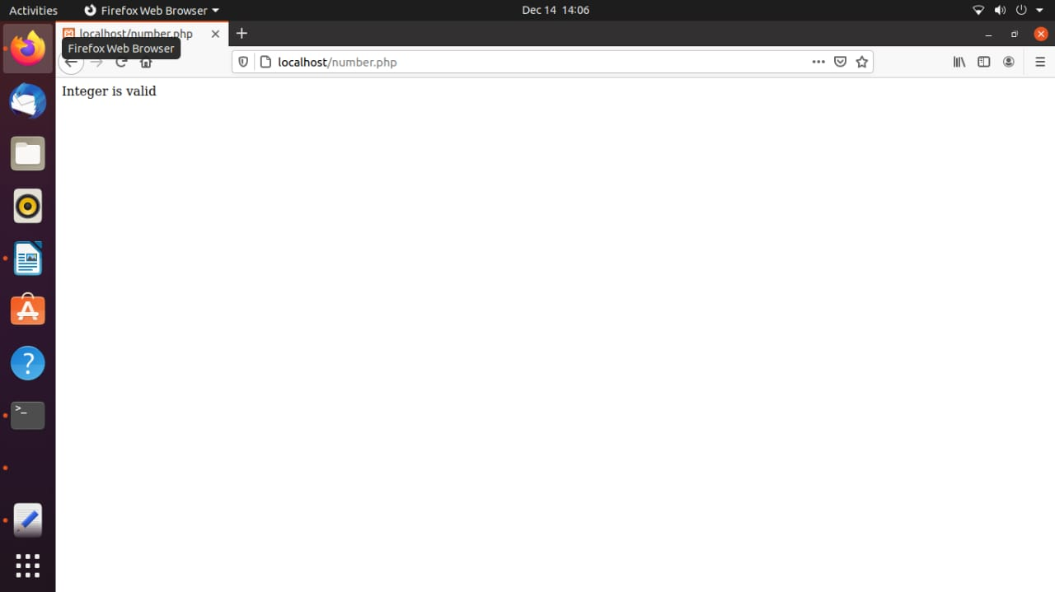



VARDHAMAN COLLEGE OF ENGINEERING

Autonomous, Shamshabad-501218.

**EXPERIMENT-05**

**5a) Write a PHP program to retrieve the data from MySQL database**

Program:

<?php

$servername="localhost";

$username="root";

$password="";

$database_name="Test_DB";

$conn=mysqli_connect($servername,$username,$password,

if (!$conn)

{

die("Connection failed: " . mysqli_connect_error);

}

$sql = "SELECT eid,ename,salary FROM Employee";

$result = $conn->query($sql);

$database_name);

if ($result->num_rows > 0) {

while($row = $result->fetch_assoc()) {

echo "id: " . $row["eid"]. " - Name: " . $row["ename"]. " " . $row["salary"].

}

} else {

echo "0 results";

}

$conn->close();

?>

**Output:**

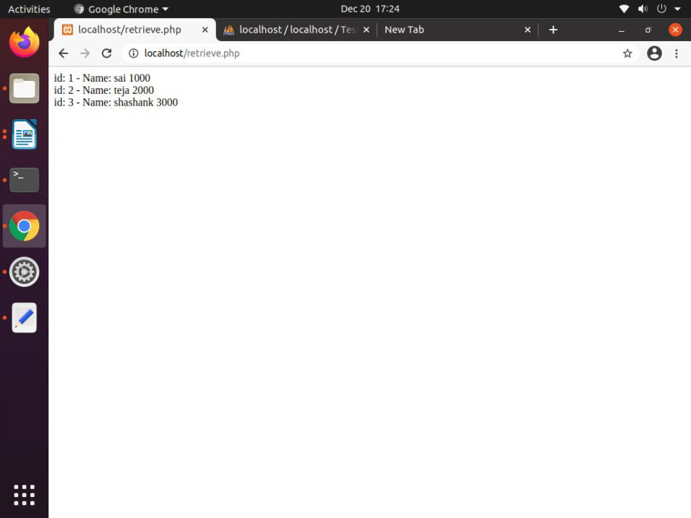



VARDHAMAN COLLEGE OF ENGINEERING

Autonomous, Shamshabad-501218.

**5b) Write a PHP program to implement sessions and cookies.**

|  |
| --- |
| **Creating a cookie**  <?php  setcookie("user_name", "Guru99", time()+ 60,'/'); // expires after 60 seconds  echo 'the cookie has been set for 60 seconds'; ?> |
| **Retrieving a cookie**  <?php print_r($_COOKIE); ?> |
| **Deleting a cookie**  <?php setcookie("user_name", "Guru99", time() - 360,'/'); ?> |
| **Creating and accessing a session**  <?php session_start(); //start the PHP_session function  if(isset($_SESSION['page_count']))  { $_SESSION['page_count'] += 1; }  else  { $_SESSION['page_count'] = 1; }  echo 'You are visitor number ' . $_SESSION['page_count']; ?> |
| **Destroying a session**  <?php session_destroy(); //destroy entire session ?> |

**Output:**

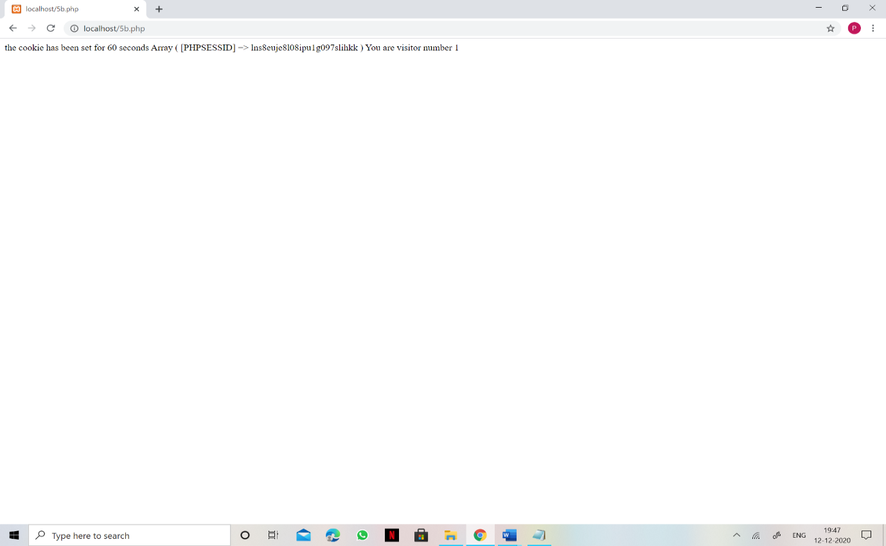



VARDHAMAN COLLEGE OF ENGINEERING

Autonomous, Shamshabad-501218.

**EXPERIMENT-06**

**6a)Write a PHP program to authenticate login credentials.**

Code:

Login.php:

<?php

if($_POST)

{

$servername="localhost";

$username="root";

$password="";

$database_name="Test_DB";

$user=$_POST['user'];

$pwd=$_POST['pwd'];

$conn=mysqli_connect($servername,$username,

$password,$database_name);

if (!$conn)

{

die("Connection failed: " . mysqli_connect_error);

}

$sql = "SELECT * from Login where user='$user' and pwd='$pwd'";

$result = mysqli_query($conn,$sql);

if(mysqli_num_rows($result)==1)

{

session_start();

$_SESSION['auth']='true';

header('location:welcome.php');

}

else

{

echo 'Wrong Username or Password! :( ' ;

}

}

?>

<html>

<head>

<title>Login Page</title>

</head>

<body>

<center>

<form method="POST" action="">VARDHAMAN COLLEGE OF ENGINEERING

Autonomous, Shamshabad-501218.

UserName:<input type="text" name="user"></br>

Password:<input type="password" name="pwd"></br>



VARDHAMAN COLLEGE OF ENGINEERING

Autonomous, Shamshabad-501218.

<input type="submit" value="submit">

</form>

</body>

</html>

welcome.php

<?php

session_start();

if(!$_SESSION['auth'])

{

header('location:login.php');

}

?>

<h1>Welcome! You are authenticated :) </h1>

**Outputs:**

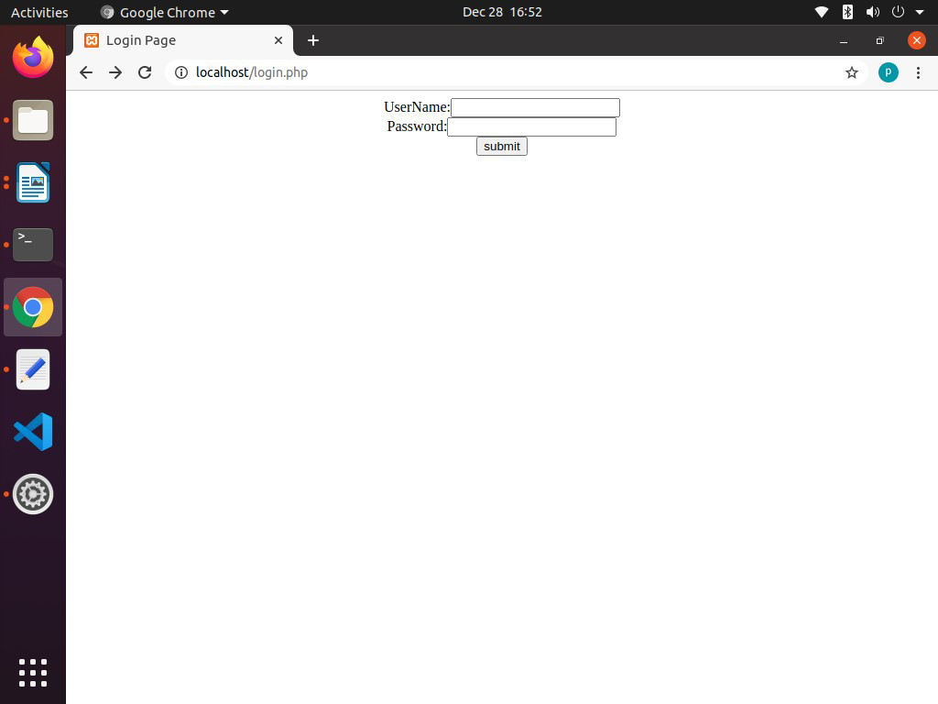



VARDHAMAN COLLEGE OF ENGINEERING

Autonomous, Shamshabad-501218.

**6b) Write a PHP program to insert the contents of student registration form**

**(Rno , name ,branch ,age , email ,and phone)into Mysql database.**

**Code:**

**stud.html:**

<html>

<head>

</head>

<body>

<h1>Enter Students Details</h1>

<center>

<form method="POST" action="insert.php">

Roll No :<input type="text" name="roll"/></br>

Name :<input type="text" name="name"/></br>

Branch :<input type="text" name="branch"/></br>

Age :<input type="text" name="age"/></br>

Email :<input type="text" name="email"/></br>

Phone :<input type="text" name="phone"/></br>

<input type="submit" value="submit">

</form>

</center>

</body>

</html>

insert.php:

<?php

$servername="localhost";

$username="root";

$password="";

$database_name="Test_DB";

$roll=$_POST['roll'];

$name=$_POST['name'];

$branch=$_POST['branch'];

$age=$_POST['age'];

$email=$_POST['email'];

$phone=$_POST['phone'];

$conn = new mysqli($servername, $username, $password,

$database_name);VARDHAMAN COLLEGE OF ENGINEERING

Autonomous, Shamshabad-501218.

if ($conn->connect_error)

{

die("Connection failed: " . $conn->connect_error);

}

$sql = "INSERT INTO Student (roll,name,branch,age,email,phone)

VALUES ('$roll','$name','$branch','$age','$email','$phone')";

if ($conn->query($sql) === TRUE)

{



VARDHAMAN COLLEGE OF ENGINEERING

Autonomous, Shamshabad-501218.

echo "New record created successfully:)";

}

else

{

echo "Error: " . $sql . "<br>" . $conn->error;

}

$conn->close();

?>

**Outputs:**

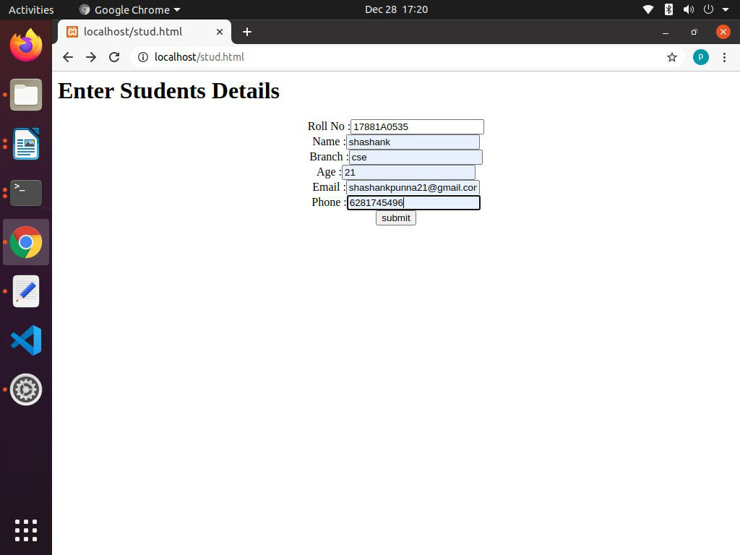

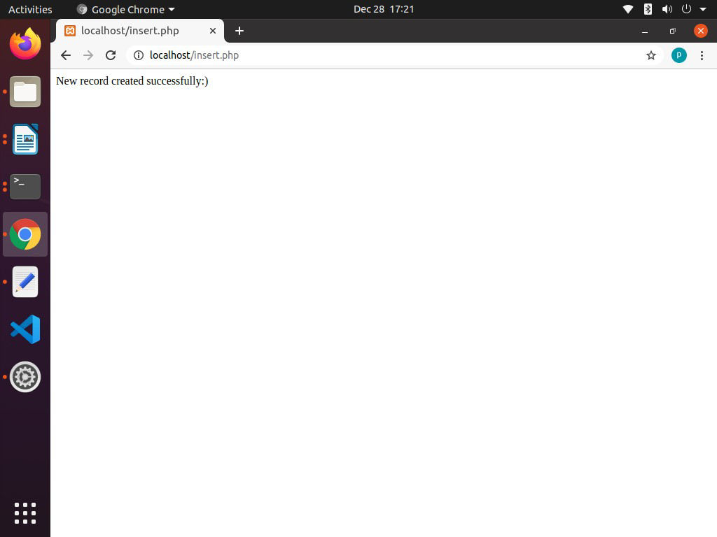



VARDHAMAN COLLEGE OF ENGINEERING

Autonomous, Shamshabad-501218.

**EXPERIMENT-07**

**7a) Write a PHP program to upload file into web server.**

**Code:**

**Upload.php:**

<?php

if(isset($_FILES['image']))

{

$errors= array();

$file_name = $_FILES['image']['name'];

$file_size =$_FILES['image']['size'];

$file_tmp =$_FILES['image']['tmp_name'];

$file_type=$_FILES['image']['type'];

$file_ext=strtolower(end(explode('.',$_FILES['image']['name'])));

$extensions= array("jpeg","jpg","png");

if(in_array($file_ext,$extensions)=== false)

{

$errors[]="extension not allowed, please choose a JPEG or PNG file.";

}

if($file_size > 2097152)

{

$errors[]='File size must be excately 2 MB';

}

if(empty($errors)==true)

{

if (move_uploaded_file($file_tmp,$file_name))

{

echo "\nThe file has been uploaded.";

}

else

{

echo "\nSorry, there was an error uploading your file.";

}

}

else

{

print_r($errors);

}

}

?>

<html>

<body>

<form action="" method="POST" enctype="multipart/form-data">

<input type="file" name="image" />



VARDHAMAN COLLEGE OF ENGINEERING

Autonomous, Shamshabad-501218.

<input type="submit"/>

</form>

<ul>

<li>Sent file: <?php echo $_FILES['image']['name']; ?>

<li>File size: <?php echo $_FILES['image']['size']; ?>

<li>File type: <?php echo $_FILES['image']['type'] ?>

</ul>

</body>

</html>

**Outputs:**

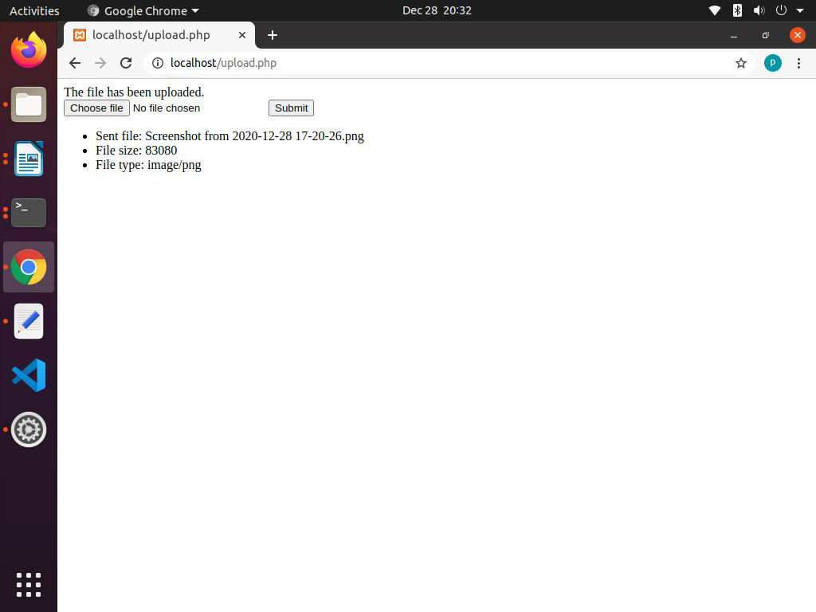

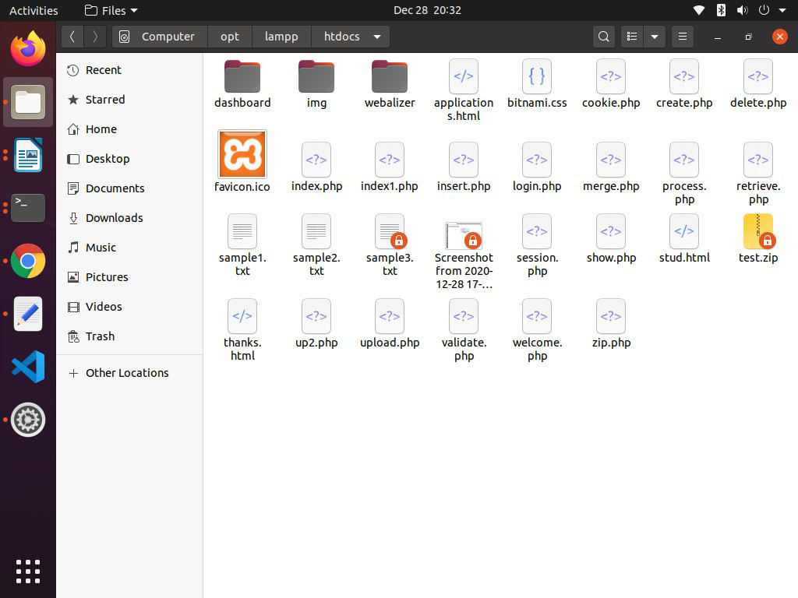



VARDHAMAN COLLEGE OF ENGINEERING

Autonomous, Shamshabad-501218.

**7b) Write a PHP program to upload image into database.**

**Code:**

**image.php:**

<html>

<head>

</head>

<body>

<form action="up.php" method="POST" enctype="multipart/form-data">

<input type="file" name="uploadfile" />

<input type="submit" name="upload"/>

</form>

<a href="disp.php">Display Image</a>

<div>

</body>

</html>

up.php:

<?php

error_reporting(0);

?>

<?php

$msg = "";

if (isset($_POST['upload']))

{

$filename = $_FILES["uploadfile"]["name"];

$tempname = $_FILES["uploadfile"]["tmp_name"];

$db = mysqli_connect("localhost", "root", "", "Test_DB");

if ($db->connect_error)

{

die("Connection failed: " . $conn->connect_error);

}

$sql = "INSERT INTO Images (image) VALUES ('$filename')";

mysqli_query($db, $sql);

if (move_uploaded_file($tempname, $filename))

{

$msg = "Image uploaded successfully";

}

else

{

$msg ="Failed to upload image";VARDHAMAN COLLEGE OF ENGINEERING

Autonomous, Shamshabad-501218.

}

echo $msg;

}

?>



VARDHAMAN COLLEGE OF ENGINEERING

Autonomous, Shamshabad-501218.

**disp.php:**

<?php

error_reporting(0);

?>

<?php

$db = mysqli_connect("localhost", "root", "", "Test_DB");

if ($db->connect_error)

{

die("Connection failed: " . $conn->connect_error);

}

$sql = "select * from Images";

$result=mysqli_query($db, $sql);

while($row=mysqli_fetch_array($result))

{

echo "<div> <img src='".$row[1]."'></div>";

}

?>

**Outputs:**

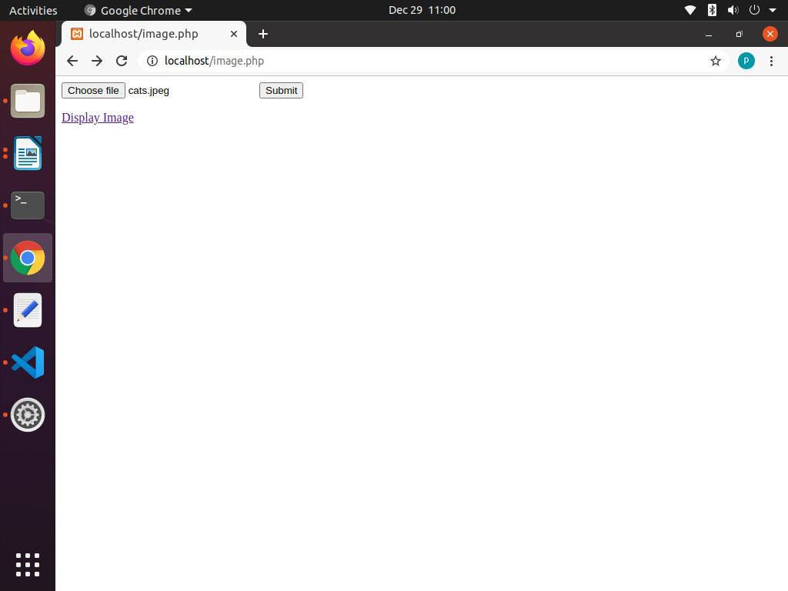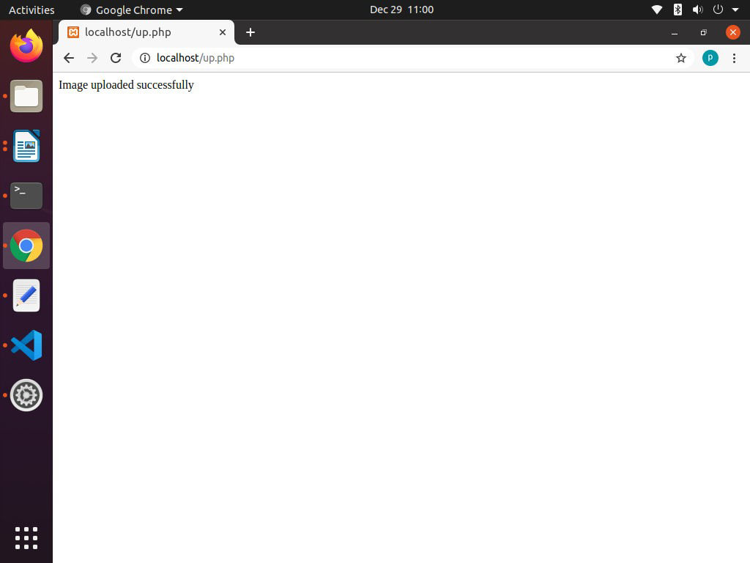

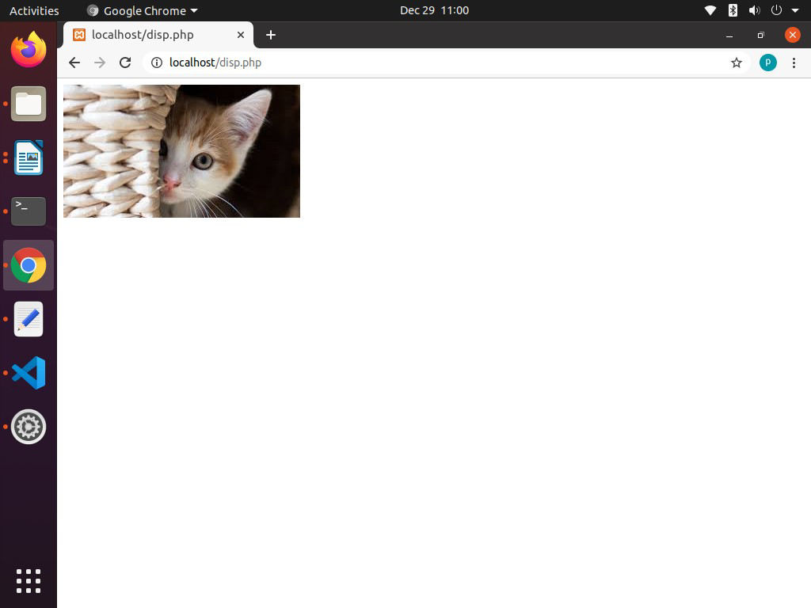



VARDHAMAN COLLEGE OF ENGINEERING

Autonomous, Shamshabad-501218.

**EXPERIMENT-08**

**8a)Write a Program to print the Fibonacci sequence using python.**

**Code:**

def fibonacci(num):

num1 = 0

num2 = 1

series = 0

for i in range(num):

print(series, end=' ');

num1 = num2;

num2 = series;

series = num1 + num2;

print('')

# running function after takking user input

num = int(input('Enter how many numbers needed in Fibonacci series- '))

fibonacci(num)

**Output:**

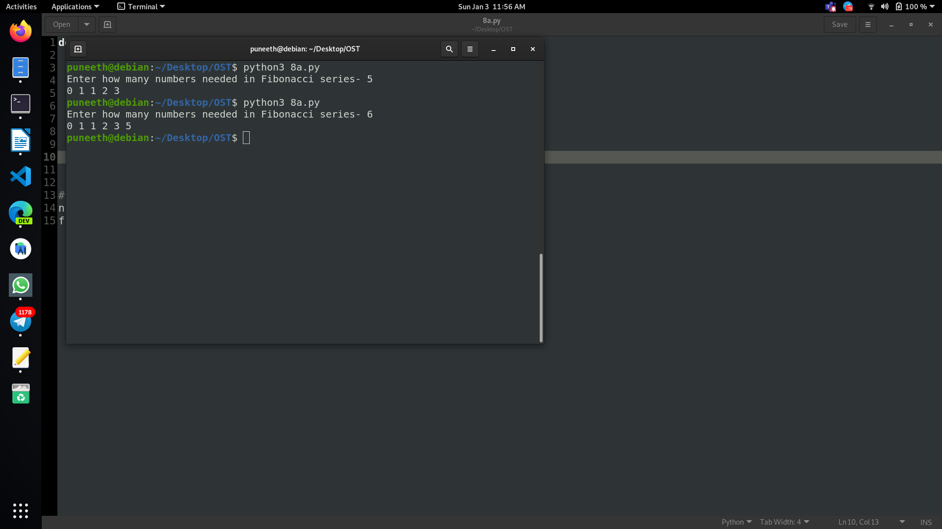



VARDHAMAN COLLEGE OF ENGINEERING

Autonomous, Shamshabad-501218.

**8b)Write a Program to display the Armstrong numbers between the specified ranges.**

**Code:**

x=int(input("lower limit: "))

y=int(input("upper limit: "))

print("Armstrong Numbers are: ")

for Number in range(x,y):

digits=0

temp=Number

while temp>0: # no of digits

digits=digits+1

temp=temp//10

sum=0

temp=Number

while temp>0: # calculate armstrong number

last_digit=temp%10

sum=sum+(last_digit**digits)

temp=temp//10

if Number == sum:

print(Number)

**Output:**

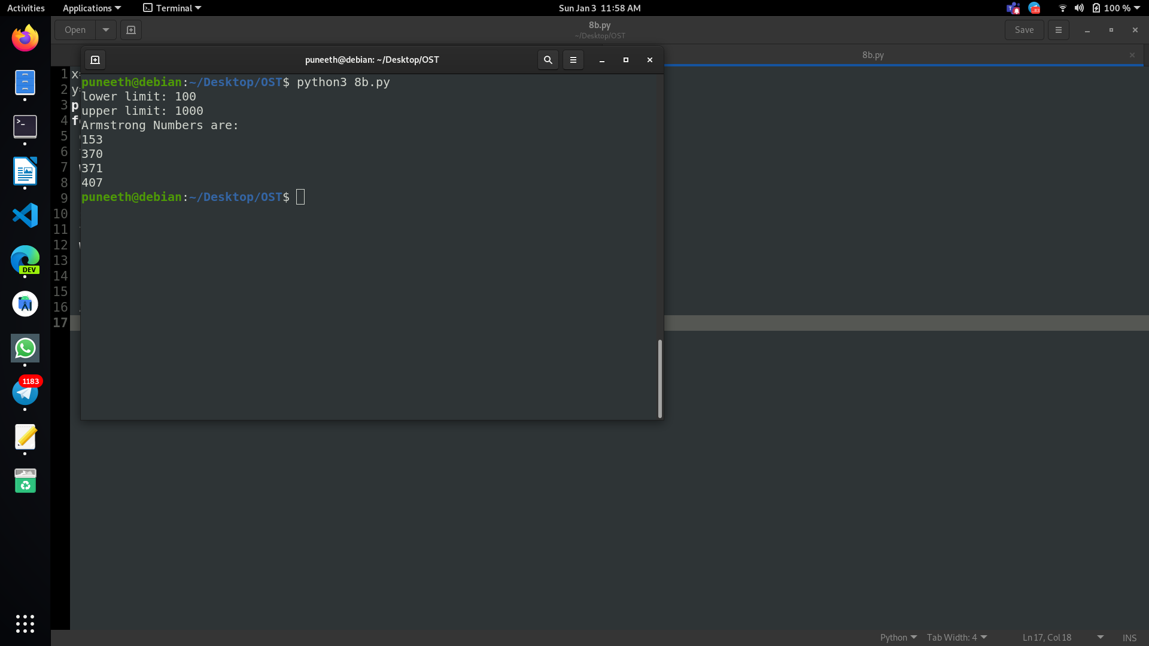



VARDHAMAN COLLEGE OF ENGINEERING

Autonomous, Shamshabad-501218.

**8c) Write a Program to perform various operations on Tuples and Dictionaries .**

**Code:**

my_tuple = ('p','e','r','m','i','t')

print(my_tuple[0])

print(my_tuple[5])

n_tuple = ("mouse", [8, 4, 6], (1, 2, 3))

print(n_tuple[0][3])

print(n_tuple[1][1])

del my_tuple

print("Dictionary Operations:")

squares = {1:1, 2:4, 3:9, 4:16, 5:25}

print(squares.pop(4))

print(squares)

print(squares.popitem())

print(squares)

#del squares[5]

print(squares)

squares.clear()

print(squares)

del squares

**Output:**

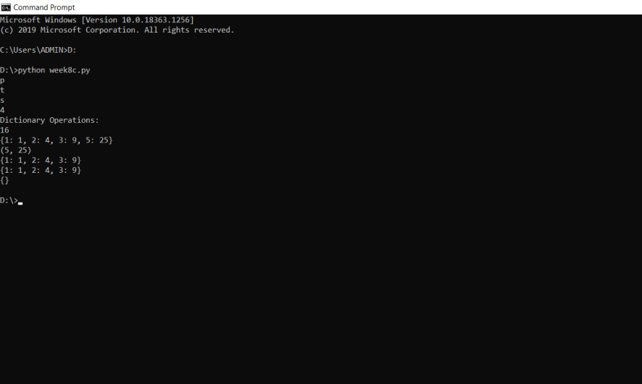



VARDHAMAN COLLEGE OF ENGINEERING

Autonomous, Shamshabad-501218.

**8d) Write a program to multiply two matrices using python.**

**Code:**

X = [[12,7,3],

[4 ,5,6],

[7 ,8,9]]

# 3x4 matrix

Y = [[5,8,1,2],

[6,7,3,0],

[4,5,9,1]]

# result is 3x4

result = [[0,0,0,0],

[0,0,0,0],

[0,0,0,0]]

# iterate through rows of X

for i in range(len(X)):

# iterate through columns of Y

for j in range(len(Y[0])):

# iterate through rows of Y

for k in range(len(Y)):

result[i][j] += X[i][k] * Y[k][j]

print("X = ",end = '')

for r in X:

print(r)

print('')

print("Y = ",end = '')

for r in Y:

print(r)

print('')

print("Result = ",end = '')

for r in result:

print(r)



VARDHAMAN COLLEGE OF ENGINEERING

Autonomous, Shamshabad-501218.

**Output:**

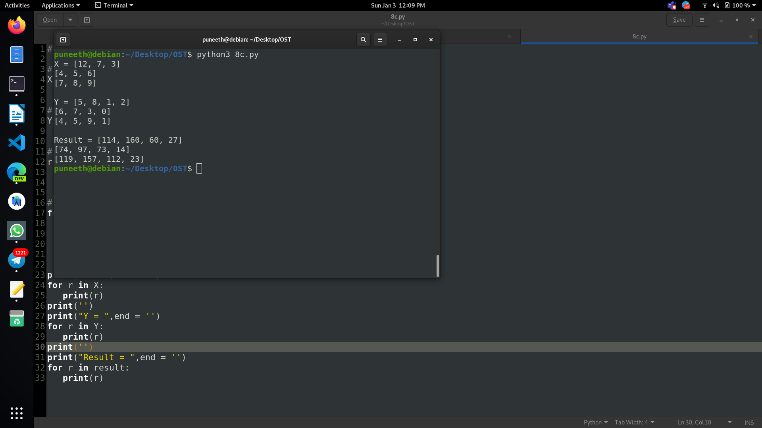



VARDHAMAN COLLEGE OF ENGINEERING

Autonomous, Shamshabad-501218.

**EXPERIMENT-09**

**9a) Write a Program to make a simple calculator using python.**

**Code:**

def add(x, y):

return x + y

# This function subtracts two numbers

def subtract(x, y):

return x - y

# This function multiplies two numbers

def multiply(x, y):

return x * y

# This function divides two numbers

def divide(x, y):

return x / y

print("Select operation.")

print("1.Add")

print("2.Subtract")

print("3.Multiply")

print("4.Divide")

while True:

# Take input from the user

choice = input("Enter choice(1/2/3/4): ")

# Check if choice is one of the four options

if choice in ('1', '2', '3', '4'):

num1 = float(input("Enter first number: "))

num2 = float(input("Enter second number: "))

if choice == '1':

print(num1, "+", num2, "=", add(num1, num2))

elif choice == '2':

print(num1, "-", num2, "=", subtract(num1, num2))

elif choice == '3':

print(num1, "*", num2, "=", multiply(num1, num2))



VARDHAMAN COLLEGE OF ENGINEERING

Autonomous, Shamshabad-501218.

elif choice == '4':

print(num1, "/", num2, "=", divide(num1, num2))

break

else:

print("Invalid Input")

**Output:**

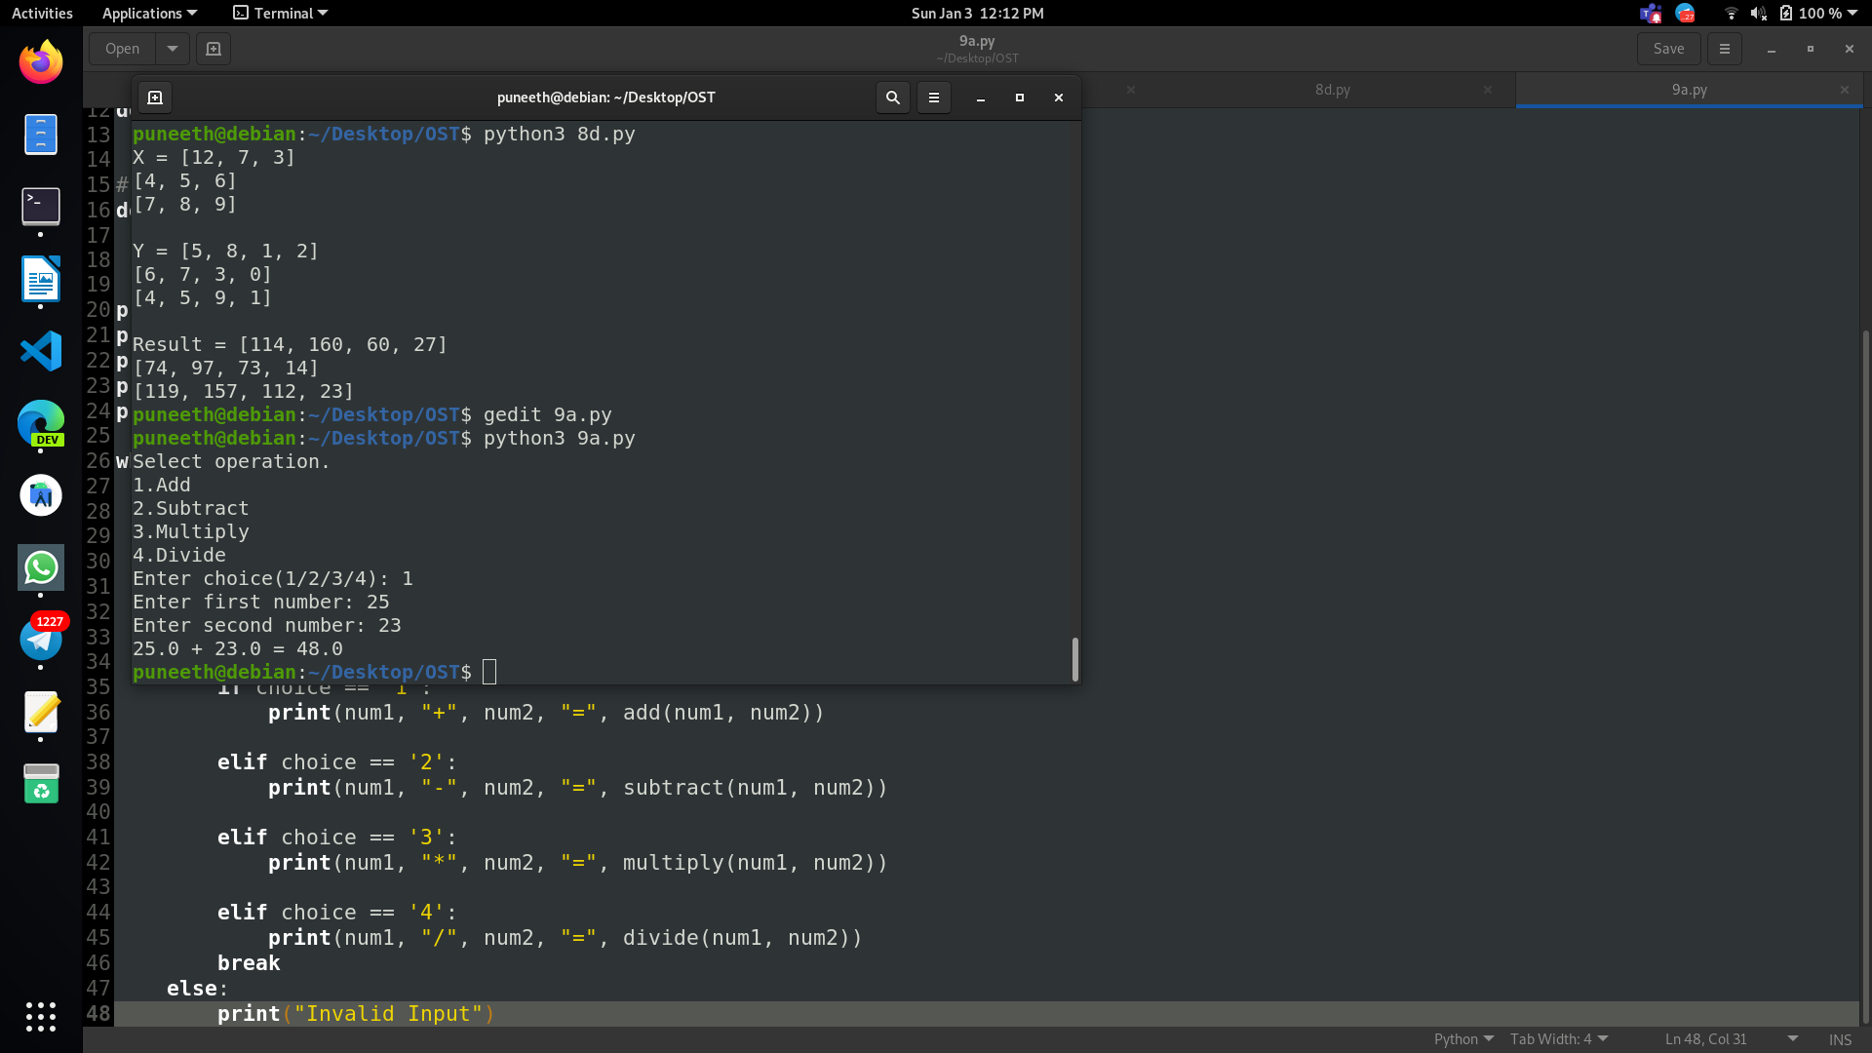



VARDHAMAN COLLEGE OF ENGINEERING

Autonomous, Shamshabad-501218.

**9b)Write a program to find maximum element in the list using recursive functions.**

**Code:**

def Max(a):

if len(a) == 1:

return a[0]

else:

m = Max(a[1:])

return m if m > a[0] else a[0]

def main():

a = input("Please enter a list of numbers: ").split(" ")

print("The largest number is: ", Max(a))

main()

**Output:**

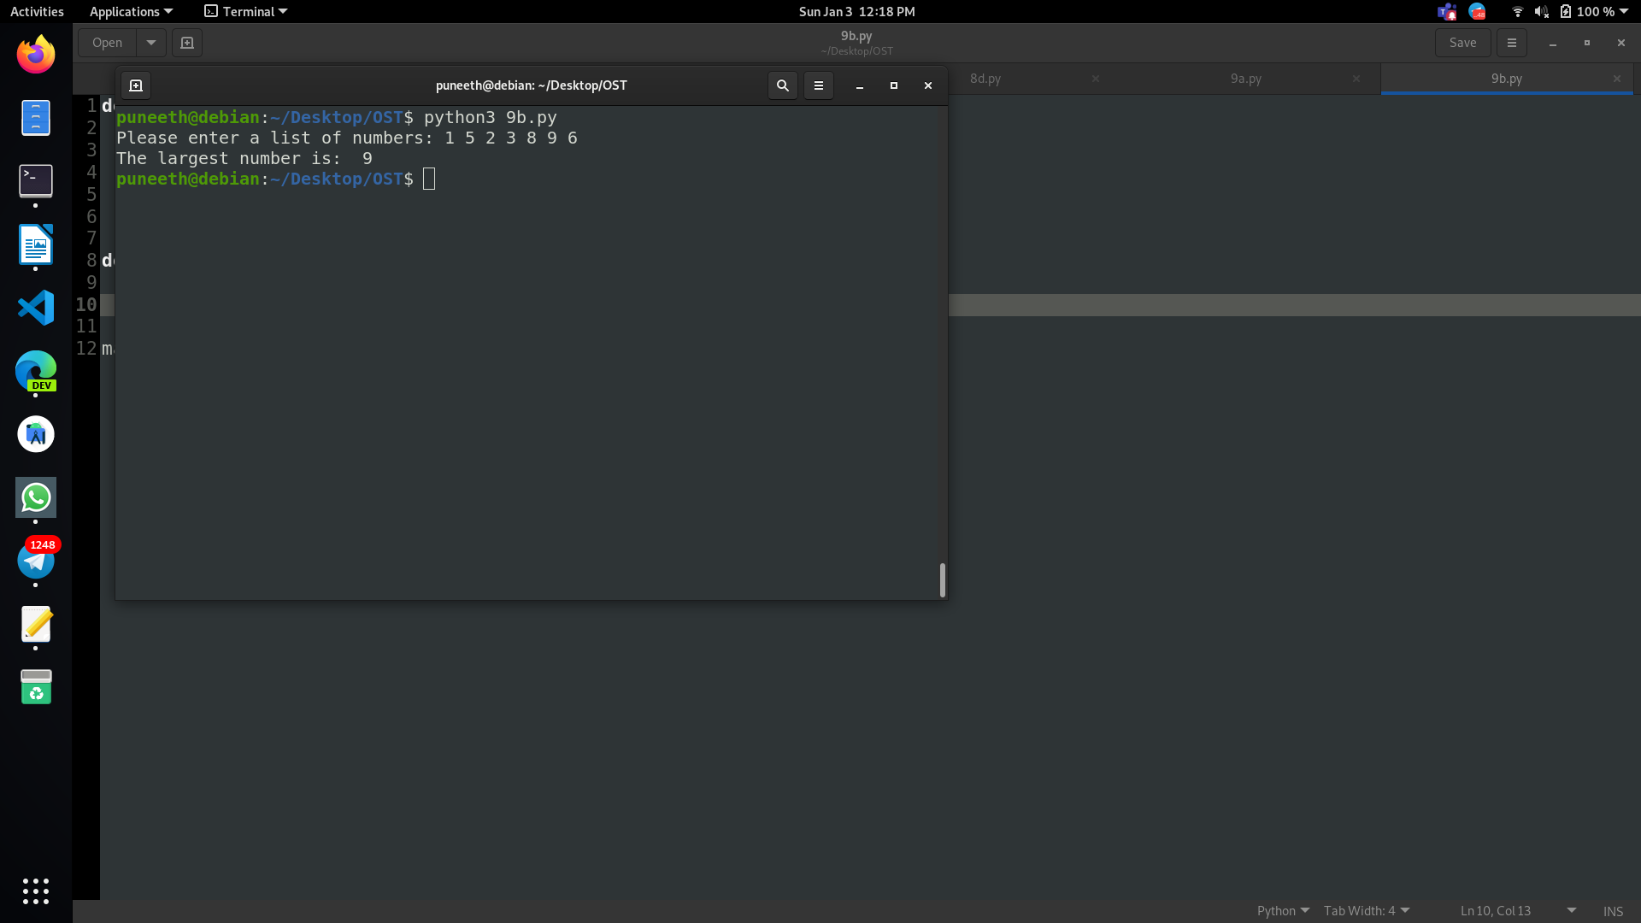



VARDHAMAN COLLEGE OF ENGINEERING

Autonomous, Shamshabad-501218.

**9c)Write a program to find GCD and LCM of two numbers using functions.**

**Code:**

def compute_gcd(x, y):

while(y):

x, y = y, x % y

return x

# This function computes LCM

def compute_lcm(x, y):

lcm = (x*y)//compute_gcd(x,y)

return lcm

num1 = int(input("1st number:"))

num2 = int(input("2nd number:"))

print("The G.C.D is:", compute_gcd(num1, num2))

print("The L.C.M is:", compute_lcm(num1, num2))

**Output:**

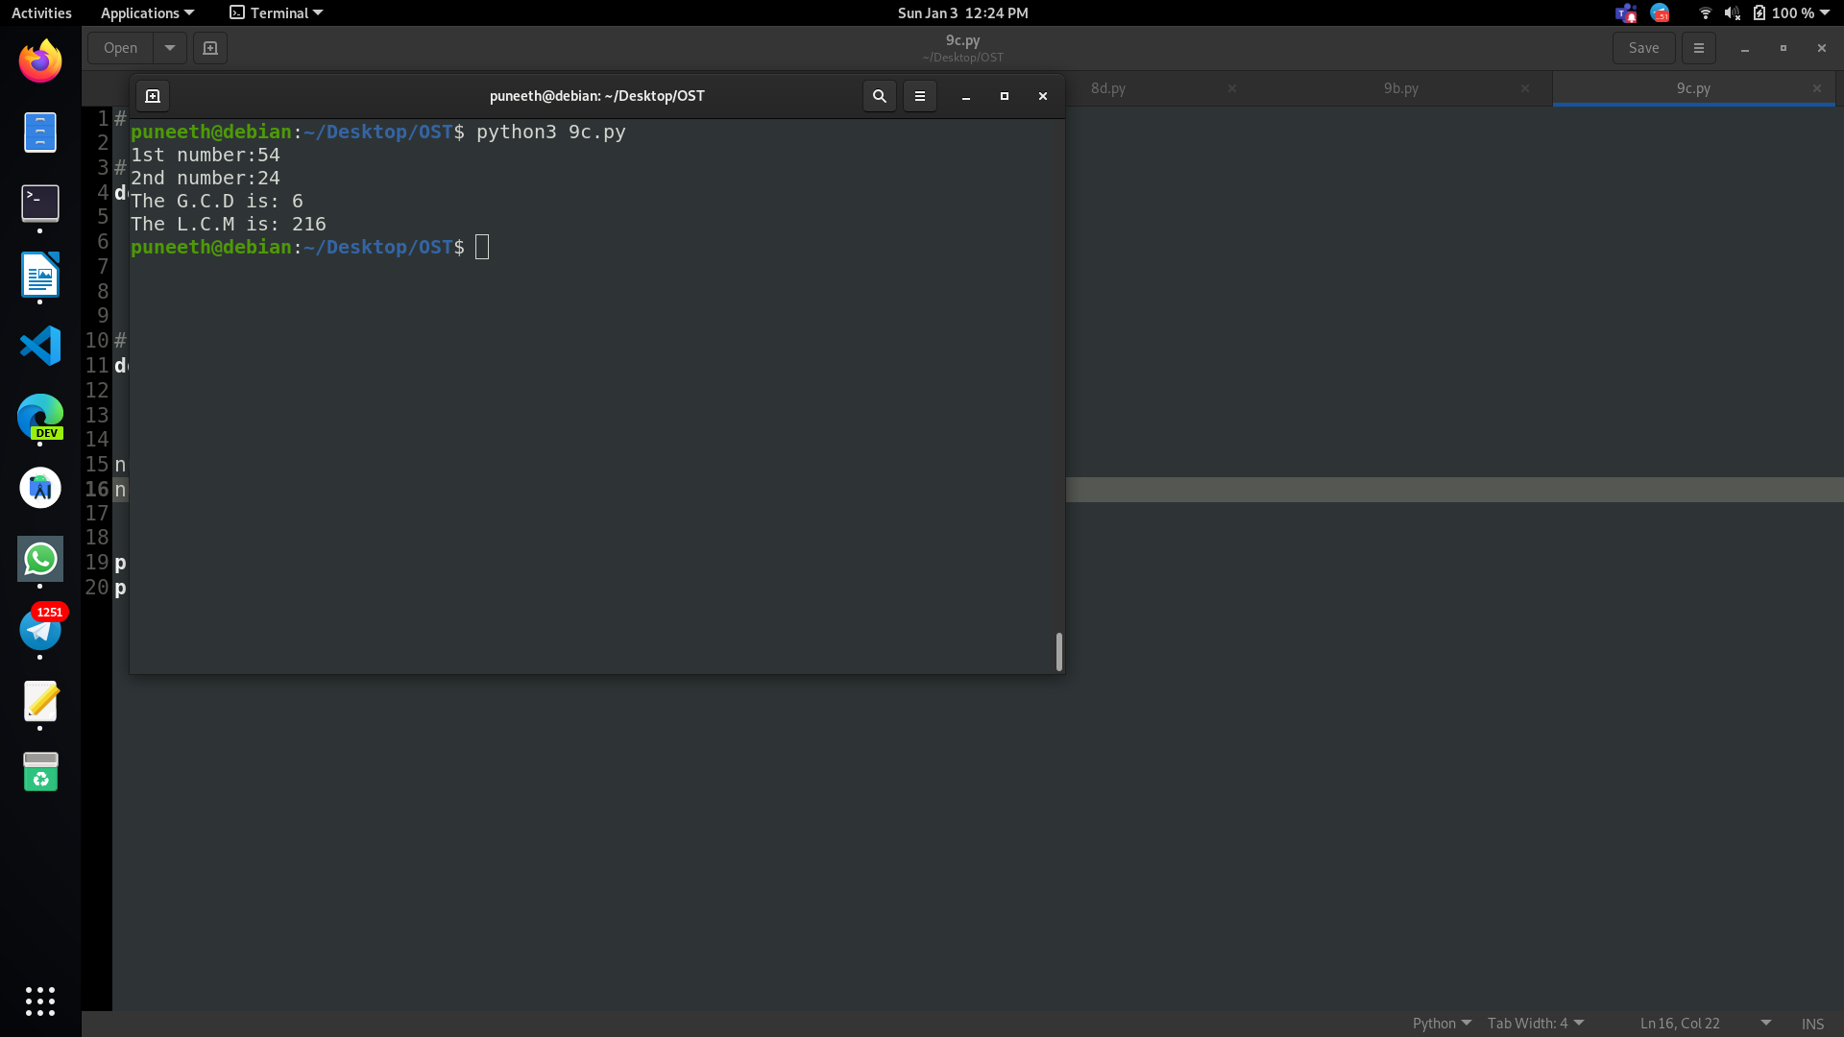



VARDHAMAN COLLEGE OF ENGINEERING

Autonomous, Shamshabad-501218.

**EXPERIMENT-10**

**10a) Write a Program to recursively calculate the sum of natural numbers using python.**

**Code:**

def recur_sum(n):

if n <= 1:

return n

else:

return n + recur_sum(n-1)

# change this value for a different result

num = int(input("Enter number:"))

if num < 0:

print("Enter a positive number")

else:

print("The sum is",recur_sum(num))

**Output:**

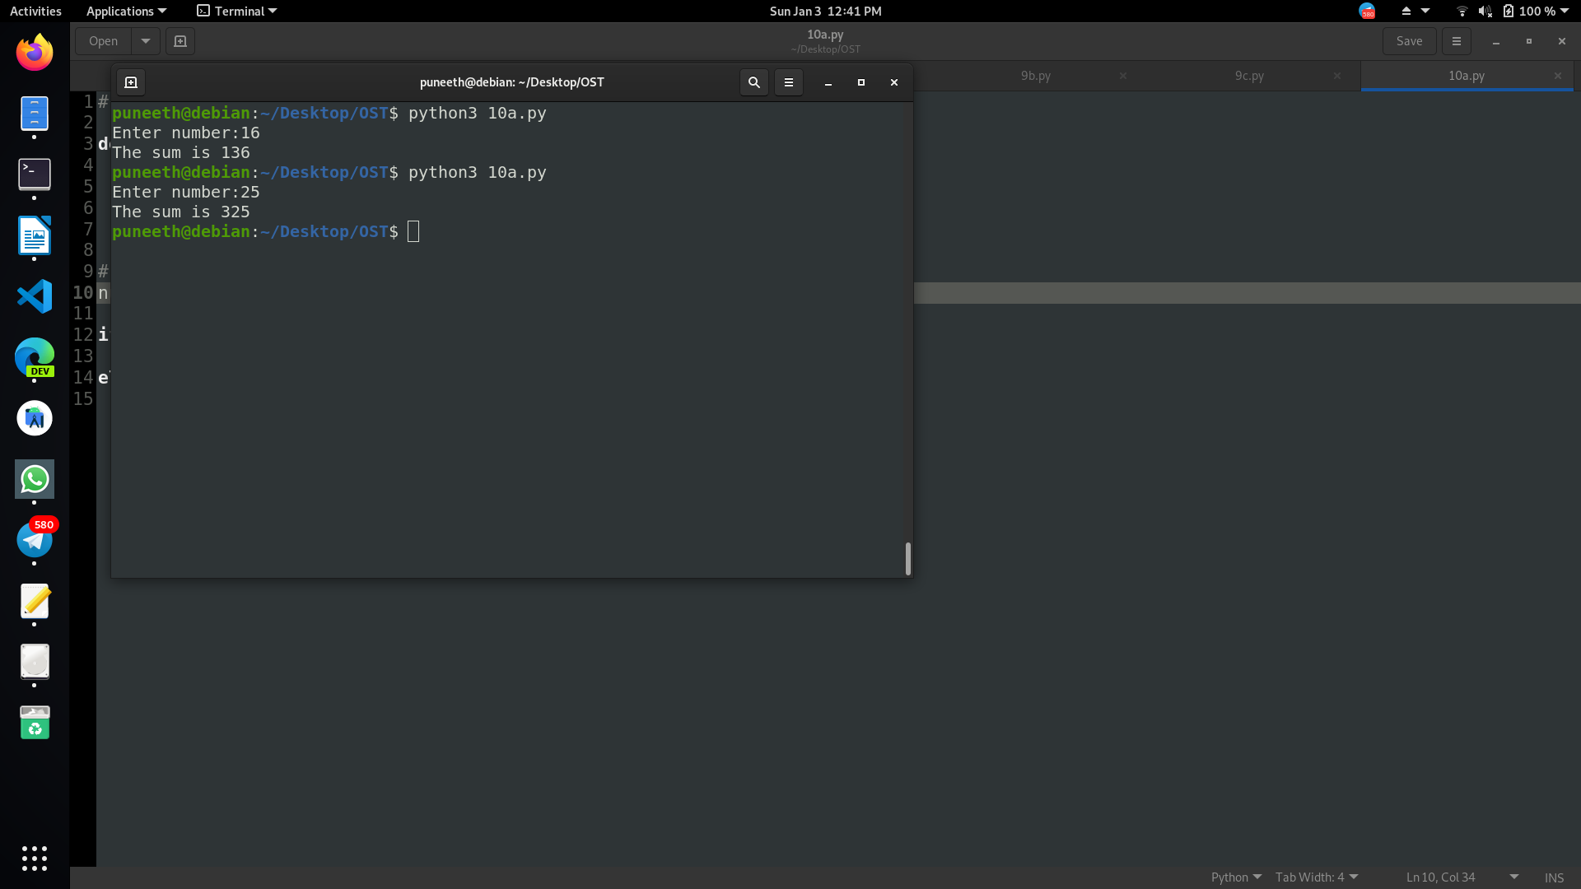



VARDHAMAN COLLEGE OF ENGINEERING

Autonomous, Shamshabad-501218.

**10b)Write a Program to sort words in alphabetic order using python.**

**Code:**

my_str= input("Enter the string to be sorted: ")

words = [word.lower() for word in my_str.split()]

words.sort()

print("The sorted words are:\n")

for word in words:

print(word,end=" ")

print("")

**Output:**

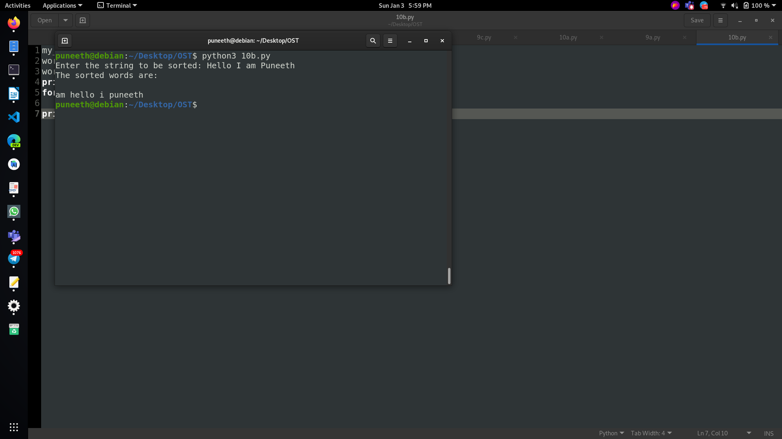



VARDHAMAN COLLEGE OF ENGINEERING

Autonomous, Shamshabad-501218.

**10c)Write a program to copy the contents from one file to another file.**

**Code:**

with open("10a.py") as f:

with open("10b.py", "w") as f1:

for line in f:

f1.write(line)

**Output:**

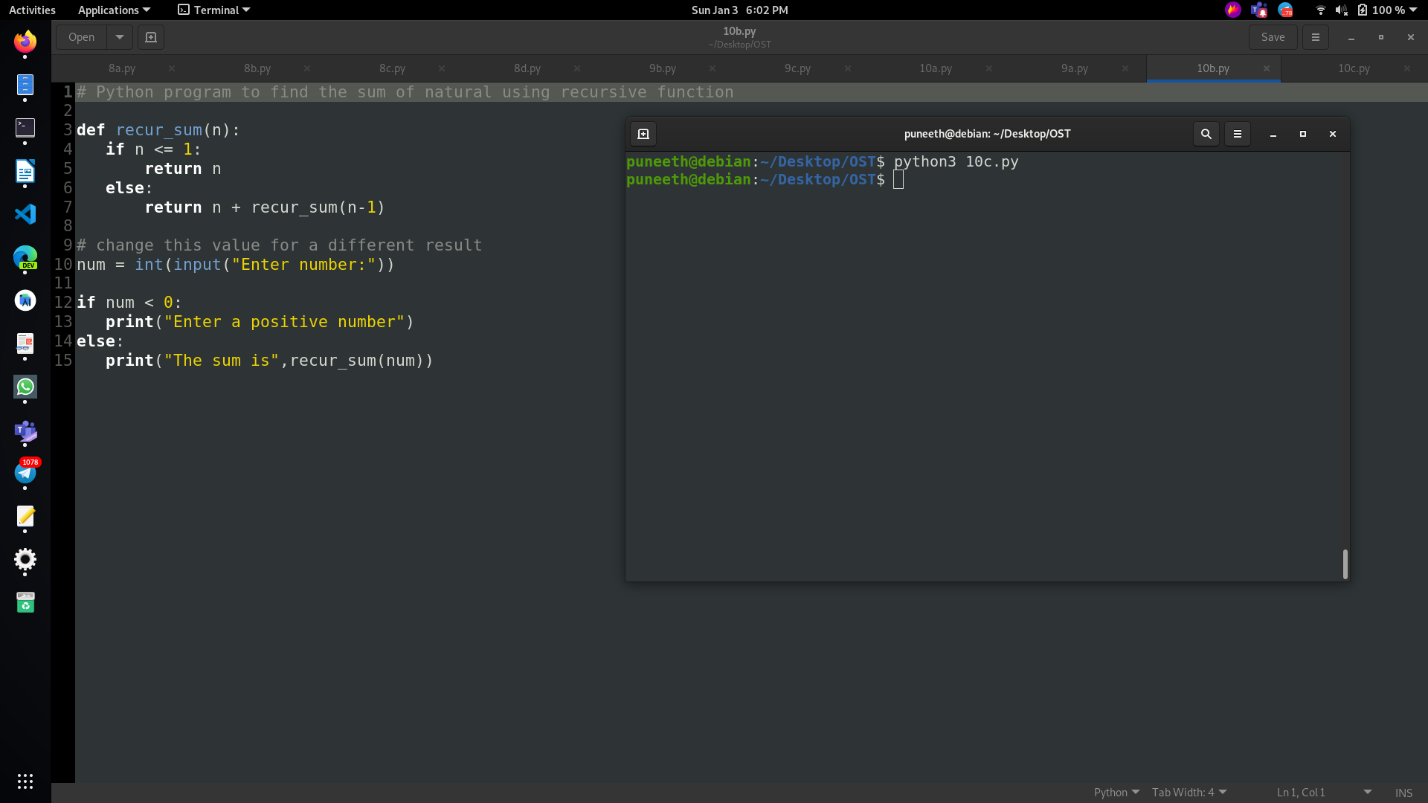



VARDHAMAN COLLEGE OF ENGINEERING

Autonomous, Shamshabad-501218.

**EXPERIMENT-11**

**11a)Write a Program to handle Exceptions using python.**

**Code:**

#!/usr/bin/python

try:

fh = open("testfile", "r")

fh.write("This is my test file for exception handling!!")

except IOError:

print("Error: can\'t find file or read data")

else:

print("Written content in the file successfully")

# define Python user-defined exceptions

class Error(Exception):

pass

class ValueTooSmallError(Error):

pass

class ValueTooLargeError(Error):

pass

# our main program

# user guesses a number until he/she gets it right

# you need to guess this number

number = 10

while True:

try:

i_num = int(input("Enter a number: "))

if i_num< number:

raise ValueTooSmallError

elif i_num> number:

raise "ValueTooLargeErrorVARDHAMAN COLLEGE OF ENGINEERING Autonomous, Shamshabad-501218."

break

except ValueTooSmallError:

print("This value is too small, try again!")

print()

except ValueTooLargeError:

print("This value is too large, try again!")

print()

else:

print("Congratulations! You guessed it correctly.")

break



VARDHAMAN COLLEGE OF ENGINEERING

Autonomous, Shamshabad-501218.

**Output:**

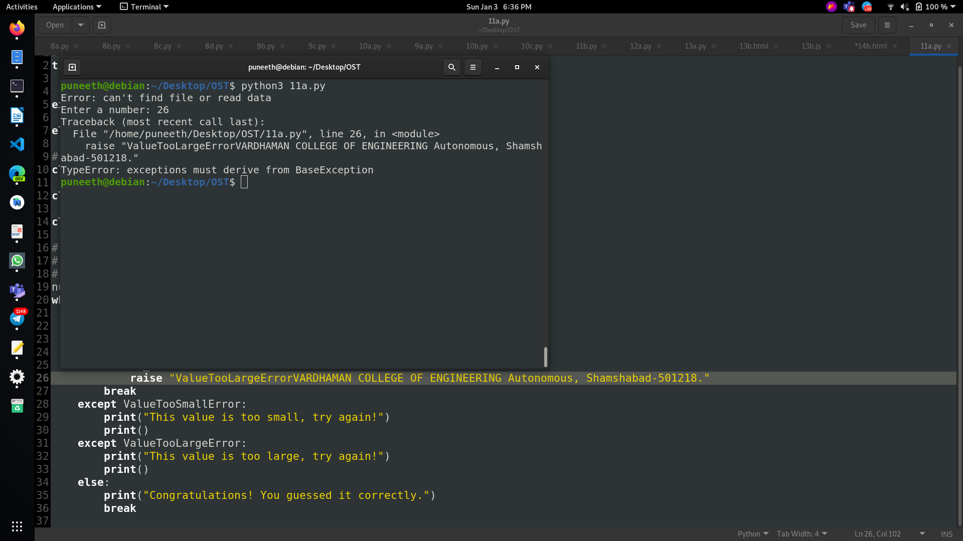



VARDHAMAN COLLEGE OF ENGINEERING

Autonomous, Shamshabad-501218.

**11b)Write a Program to display Powers of 2 Using Anonymous Function using python.**

**Code:**

terms = int(input("How many terms? "))

result = list(map(lambda x: 2 ** x, range(terms)))

print("The total terms is:",terms)

for i in range(terms):

print("2 raised to power",i,"is",result[i])

**Output:**

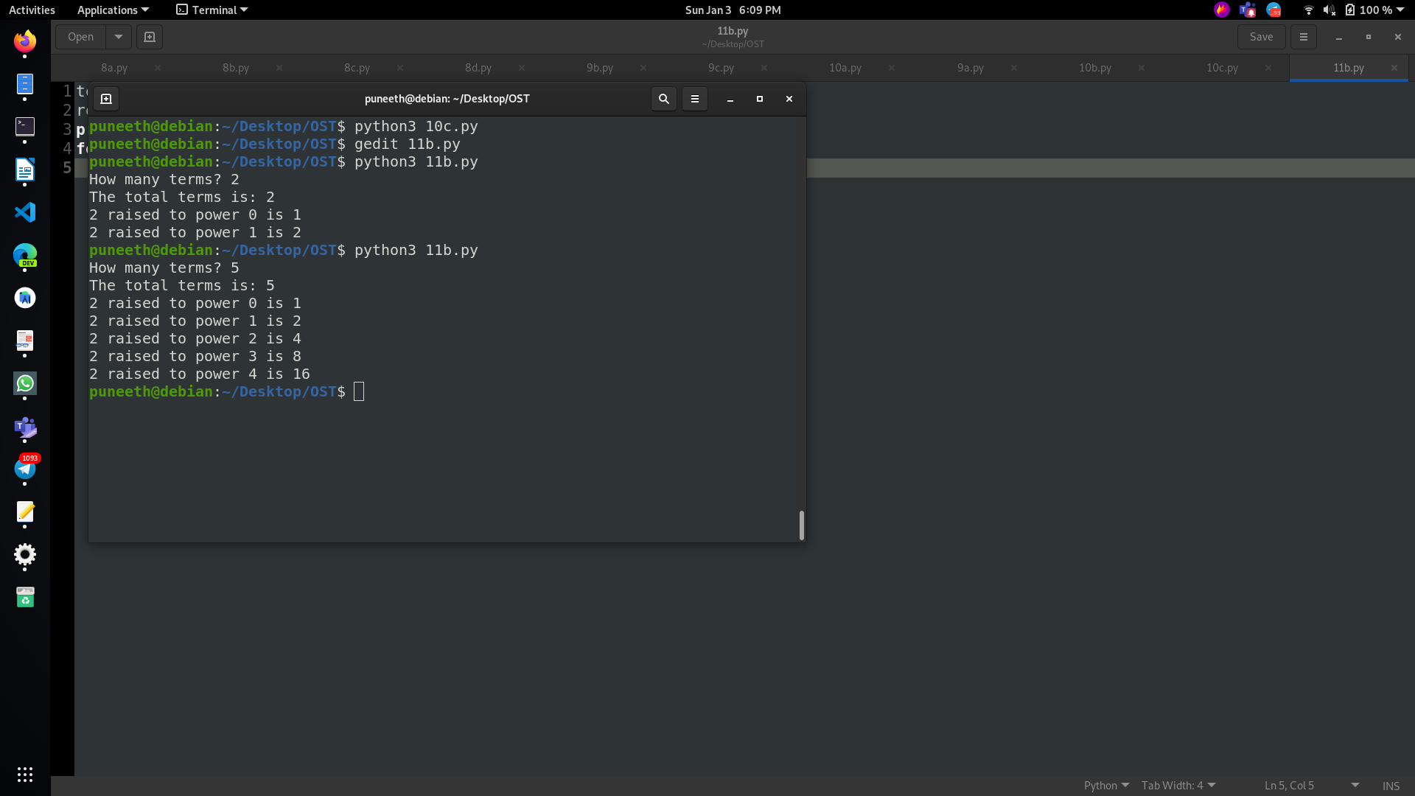



VARDHAMAN COLLEGE OF ENGINEERING

Autonomous, Shamshabad-501218.

**EXPERIMENT-12**

**12a) Write a Program to create a form controls using tkinter.**

**Code:**

ffrom tkinter import *

from tkinter import messagebox

root = Tk()

root.geometry("500x500")

root.title('Registration form')

label_0 =Label(root,text="Registration form", width=20,font=("bold",20))

label_0.place(x=90,y=60)

label_1 =Label(root,text="FullName", width=20,font=("bold",10))

label_1.place(x=80,y=130)

entry_1=Entry(root)

entry_1.place(x=240,y=130)

label_3 =Label(root,text="Email", width=20,font=("bold",10))

label_3.place(x=68,y=180)

entry_3=Entry(root)

entry_3.place(x=240,y=180)

label_4 =Label(root,text="Gender", width=20,font=("bold",10))

label_4.place(x=70,y=230)

var=IntVar()

Radiobutton(root,text="Male",padx= 5, variable= var, value=1).place(x=235,y=230)

Radiobutton(root,text="Female",padx= 20, variable= var,

value=2).place(x=290,y=230)

label_5=Label(root,text="Country",width=20,font=("bold",10))

label_5.place(x=70,y=280)

list_of_country=[ 'India' ,'US' , 'UK' ,'Germany' ,'Austria']

c=StringVar()

droplist=OptionMenu(root,c, *list_of_country)

droplist.config(width=15)

c.set('Select your Country')

droplist.place(x=240,y=280)

label_6=Label(root,text="Language",width=20,font=('bold',10))

label_6.place(x=75,y=330)

var1=IntVar()

Checkbutton(root,text="English", variable=var1).place(x=230,y=330)

var2=IntVar()

Checkbutton(root,text="German", variable=var2).place(x=290,y=330)

def Button1():

a=entry_1.get()

messagebox.showinfo("Greeting","Hello "+a)

Button(root, text='Submit' ,

width=20,bg="black",fg='white',command=Button1).place(x=180,y=380)

root.mainloop()



VARDHAMAN COLLEGE OF ENGINEERING

Autonomous, Shamshabad-501218.

**Output:**

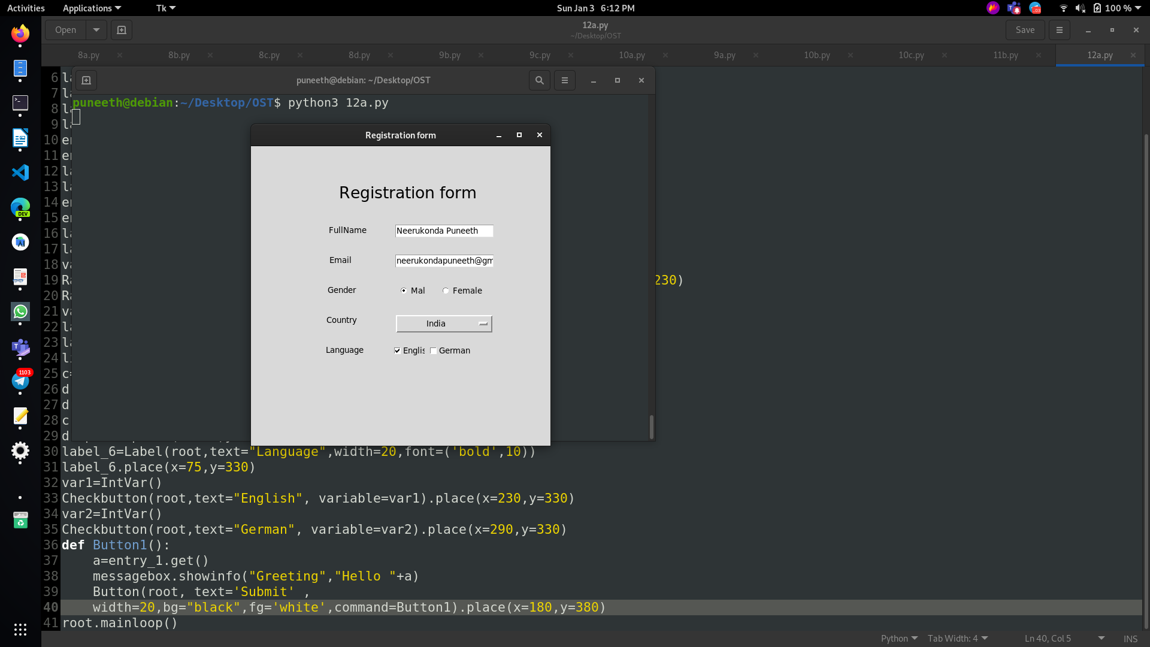



VARDHAMAN COLLEGE OF ENGINEERING

Autonomous, Shamshabad-501218.

**12b) Write a program to access Mysql DB using Python.**

**Code:**

import MySQLdb

db = MySQLdb.connect("localhost","root","","526db" )

# prepare a cursor object using cursor() method

cursor = db.cursor()

# Prepare SQL query to INSERT a record into the database.

sql = """INSERT INTO student(id,

name, age)

VALUES (500,'xyz',20)"""

try:

# Execute the SQL command

cursor.execute(sql)

# Commit your changes in the database

db.commit()

except:

# Rollback in case there is any error

db.rollback()

# disconnect from server

#insert

sql1 = "SELECT * FROM student \

WHERE age > 19"

try:

# Execute the SQL command

cursor.execute(sql1)

# Fetch all the rows in a list of lists.

results = cursor.fetchall()

for row in results:

id = row[0]

name=row[1]

age = row[2]

# Now print fetched result

print (id,name,age)

except:

print ("Error: unable to fecth data")

# disconnect from server

db.close()



VARDHAMAN COLLEGE OF ENGINEERING

Autonomous, Shamshabad-501218.

**Output:**

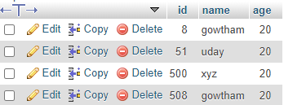

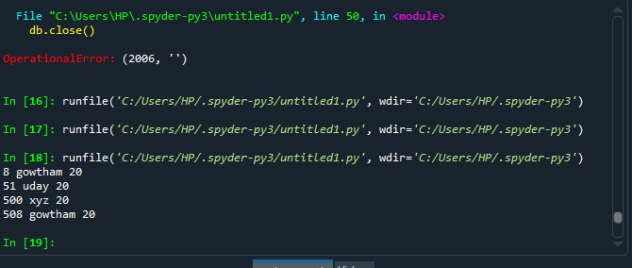



VARDHAMAN COLLEGE OF ENGINEERING

Autonomous, Shamshabad-501218.

**EXPERIMENT-13**

**13a)Write a JQuery Script to implement hide() and show()effects.**

**Code:**

<html>

<head>

<script>

$(document).ready(function(){

$("#hide").click(function(){

$("p").hide();

});

$("#show").click(function(){

$("p").show();

});

});

</script>

</head>

<body>

<p>If you click on the "Hide" button, I will disappear.</p>

<button id="hide">Hide</button>

<button id="show">Show</button>

</body>

</html>

**Output:**







VARDHAMAN COLLEGE OF ENGINEERING

Autonomous, Shamshabad-501218.

**13b) Write a JQuery Script to apply various sliding effects**

**Code:**

<html>

<head>

<style>

#panel, #flip {

padding: 5px;

text-align: center;

background-color: #e5eecc;

border: solid 1px #c3c3c3;

}

#panel {

padding: 50px;

display: none;

}

</style>

<script

src="https://ajax.googleapis.com/ajax/libs/jquery/3.5.1/jquery.min.js"></

script>

<script src="13b.js"></script>

</head>

<body>

<div id="flip">Click to slide the panel down or up</div>

<div id="panel">Hello world!</div>

</body>

</html>

**13b.js:**

$(document).ready(function(){

$("#flip").click(function(){

$("#panel").slideToggle("slow");

});

});

**Output:**

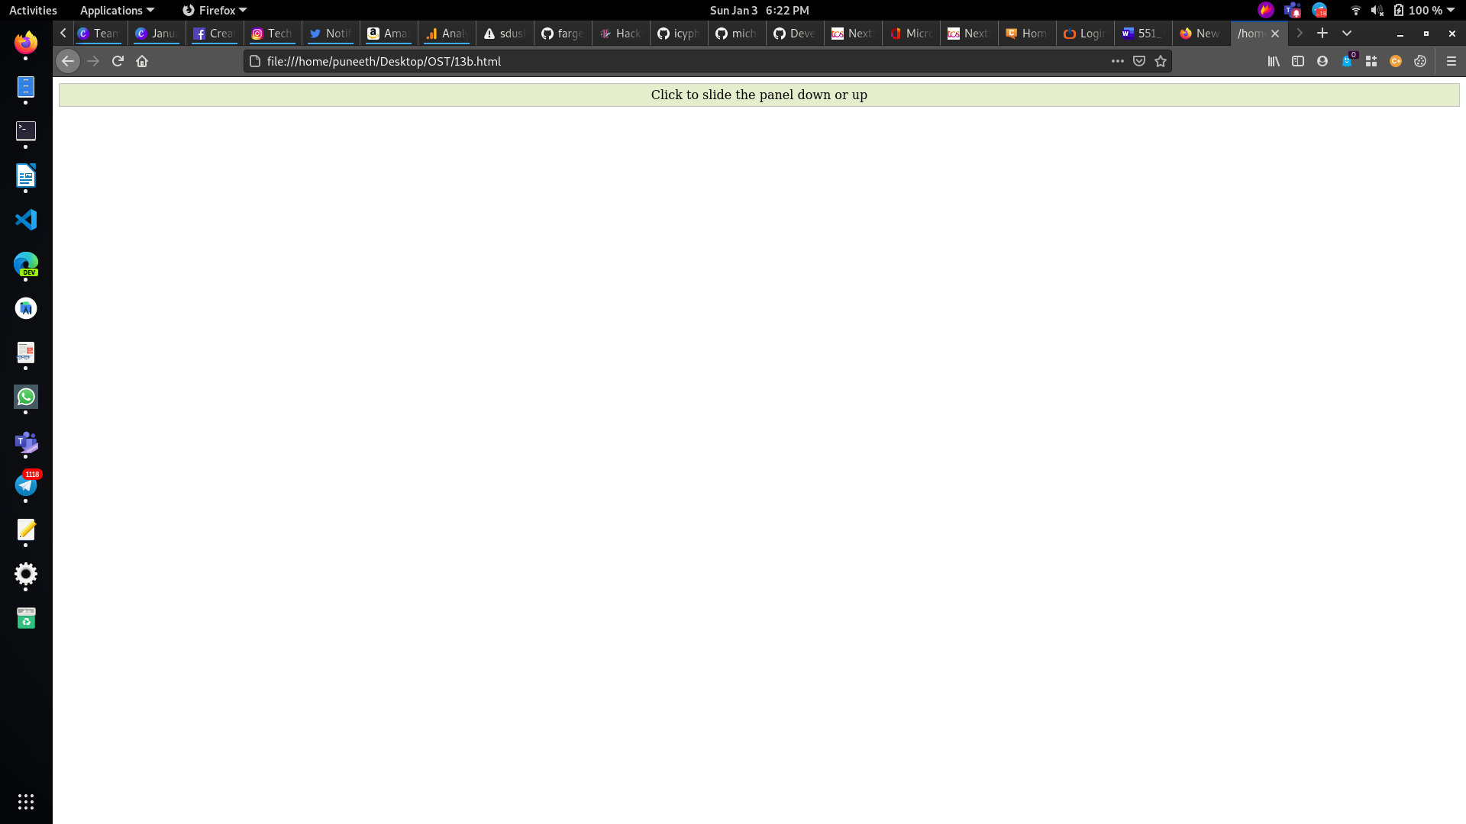



VARDHAMAN COLLEGE OF ENGINEERING

Autonomous, Shamshabad-501218.

**EXPERIMENT-14**

**14a) Write a Jquery script to animate the given image when ever user clicks on a button.**

**Code:**

**animate.html:**

<html>

<head>

<title>The jQuery Example</title>

<style>

.clickme{

margin:10px;

padding:12px;

border:2px solid #666;

width:100px;

height:50px;

}

</style>

<script

src="https://ajax.googleapis.com/ajax/libs/jquery/3.5.1/jquery.min.js"></

script>

<script src="animate.js"></script>

</head>

<body>

<div class = "content">

<div class = "clickme">Click Me</div>

<div class = "target">

<img src = "cats.jpeg" alt = "CAT" />

</div>

<div class = "log"></div>

</div>

</body>

</html>

**animate.js:**

$(document).ready(function() {

$(".clickme").click(function(event){

$(".target").toggle('slow', function(){

$(".log").text('Transition Complete');

});

});

});



VARDHAMAN COLLEGE OF ENGINEERING

Autonomous, Shamshabad-501218.

**Output:**

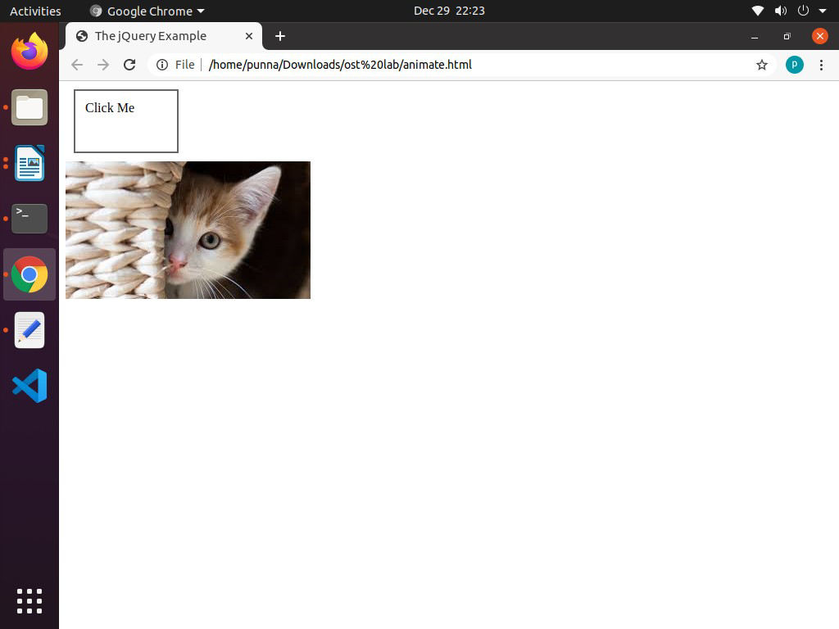

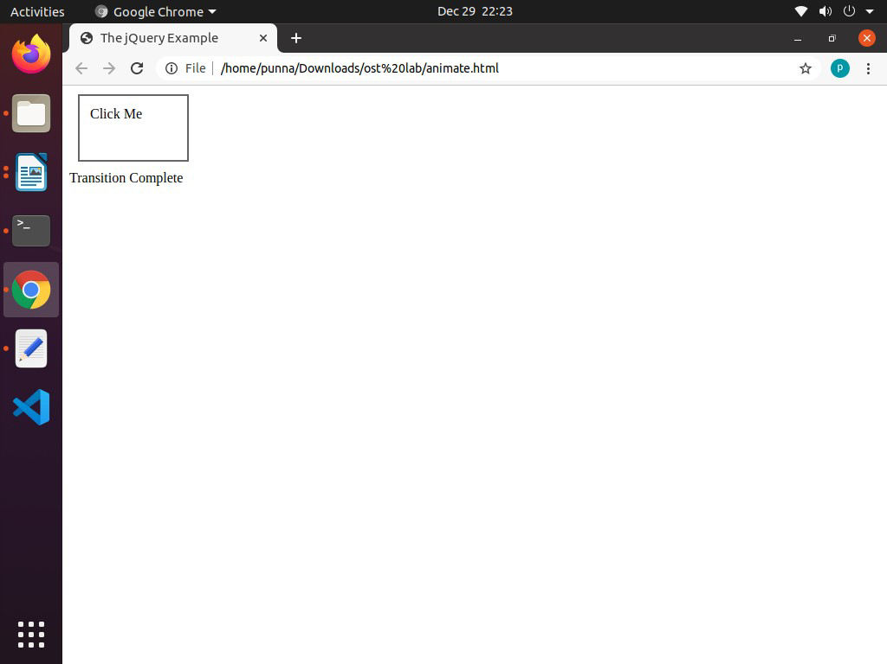



VARDHAMAN COLLEGE OF ENGINEERING

Autonomous, Shamshabad-501218.

**14b) Write a JQuery script to apply various CSS effects.**

**Code:**

<html>

<head>

<script src="https://ajax.googleapis.com/ajax/libs/jquery/3.5.1/jquery.min.js"></script>

<script>

$(document).ready(function(){

$("button").click(function(){

$("p").css({"background-color": "yellow", "font-size": "200%"});

});

});

</script>

</head>

<body>

<h2>This is a heading</h2>

<p style="background-color:#ff0000">This is a paragraph.</p>

<p style="background-color:#00ff00">This is a paragraph.</p>

<p style="background-color:#0000ff">This is a paragraph.</p>

<p>This is a paragraph.</p>

<button>Set multiple styles for p</button>

</body>

</html>

**Output:**

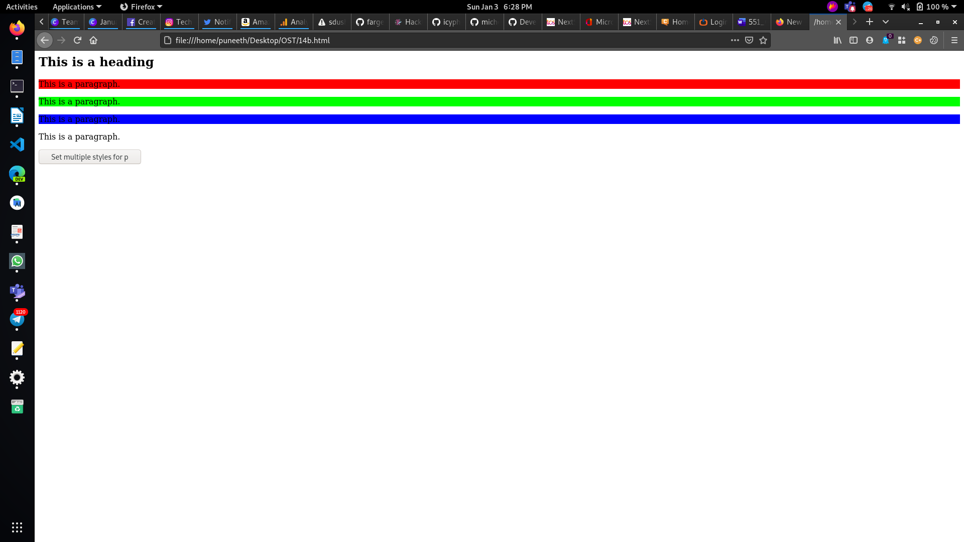

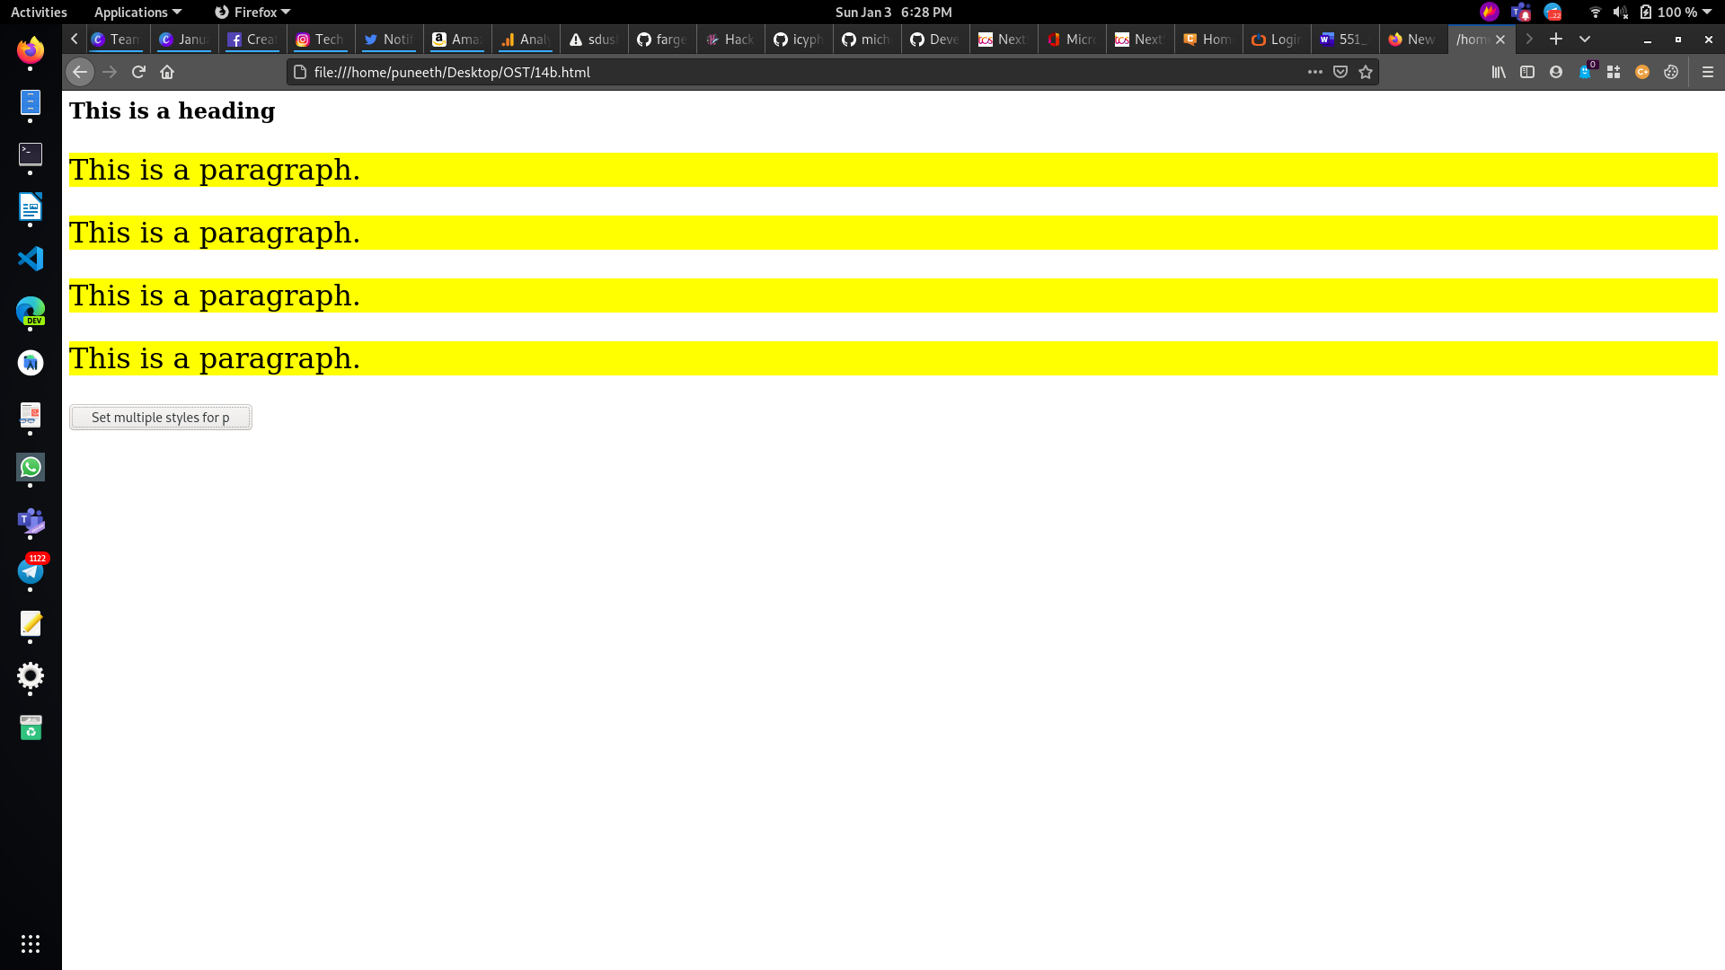



VARDHAMAN COLLEGE OF ENGINEERING

Autonomous, Shamshabad-501218.

**EXPERIMENT-15**

**15a) Write a program to apply various filters to transform data.**

**Code:**

<!DOCTYPE html>

<html>

<script src="https://ajax.googleapis.com/ajax/libs/angularjs/1.6.4/angular.min.js"></script>

<body>

<div ng-app="myApp" ng-controller="namesCtrl">

<p>Type a letter in the input field:</p>

<p><input type="text" ng-model="test"></p>

<ul>

<li ng-repeat="x in names | filter:test">

{{ x }}

</li>

</ul>

</div>

<script>

angular.module('myApp', []).controller('namesCtrl', function($scope) {

$scope.names = [

'Jani',

'Carl',

'Margareth',

'Hege',

'Joe',

'Gustav',

'Birgit',

'Mary',

'Kai'

];

});

</script>

<p>The list will only consists of names matching the filter.</p>

</body>

</html>



VARDHAMAN COLLEGE OF ENGINEERING

Autonomous, Shamshabad-501218.

**Output:**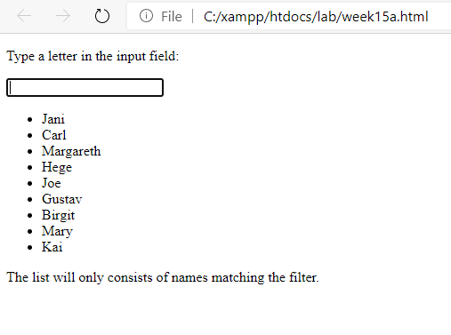



VARDHAMAN COLLEGE OF ENGINEERING

Autonomous, Shamshabad-501218.

**15b) Write a program to display data in tables in various forms**

**Code:**

<html>

<head>

<title>Angular JS Table</title>

<script src = "https://ajax.googleapis.com/ajax/libs/angularjs/1.3.14/angular.min.js"></script>

<style>

table, th , td {

border: 1px solid grey;

border-collapse: collapse;

padding: 5px;

}

table tr:nth-child(odd) {

background-color: #f2f2f2;

}

table tr:nth-child(even) {

background-color: #ffffff;

}

</style>

</head>

<body>

<h2>AngularJS Sample Application</h2>

<div ng-app = "mainApp" ng-controller = "studentController">

<table border = "0">

<tr>

<td>Enter first name:</td>

<td><input type = "text" ng-model = "student.firstName"></td>

</tr>

<tr>

<td>Enter last name: </td>

<td>

<input type = "text" ng-model = "student.lastName">

</td>

</tr>

<tr>

<td>Name: </td>

<td>{{student.fullName()}}</td>



VARDHAMAN COLLEGE OF ENGINEERING

Autonomous, Shamshabad-501218.

</tr>

<tr>

<td>Subject:</td>

<td>

<table>

<tr>

<th>Name</th>.

<th>Marks</th>

</tr>

<tr ng-repeat = "subject in student.subjects">

<td>{{ subject.name }}</td>

<td>{{ subject.marks }}</td>

</tr>

</table>

</td>

</tr>

</table>

</div>

<script>

var mainApp = angular.module("mainApp", []);

mainApp.controller('studentController', function($scope) {

$scope.student = {

firstName: "Mahesh",

lastName: "Parashar",

fees:500,

subjects:[

{name:'Physics',marks:70},

{name:'Chemistry',marks:80},

{name:'Math',marks:65},

{name:'English',marks:75},

{name:'Hindi',marks:67}

],

fullName: function() {

var studentObject;



VARDHAMAN COLLEGE OF ENGINEERING

Autonomous, Shamshabad-501218.

studentObject = $scope.student;

return studentObject.firstName + " " + studentObject.lastName;

}

};

});

</script>

</body>

</html>

**Output:**

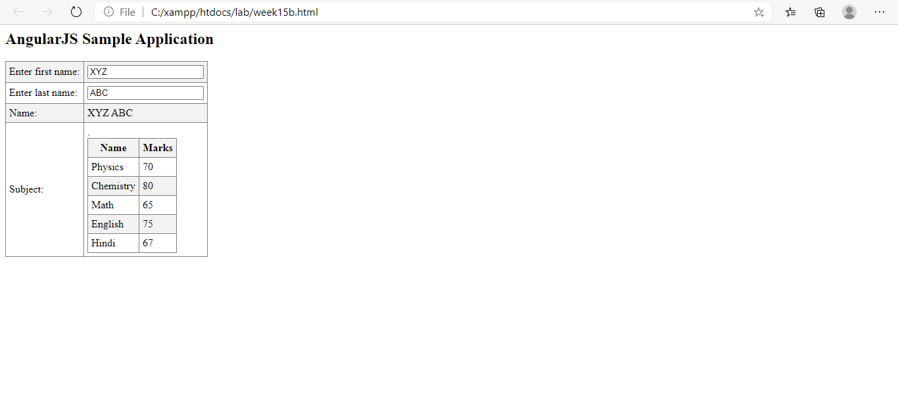



VARDHAMAN COLLEGE OF ENGINEERING

Autonomous, Shamshabad-501218.

**15c) Write a program to apply animations**

<!DOCTYPE html>

<html>

<style>

div {

transition: all linear 0.5s;

background-color: lightblue;

height: 100px;

width: 100%;

position: relative;

top: 0;

left: 0;

}

.ng-hide {

height: 0;

width: 0;

background-color: transparent;

top:-200px;

left: 200px;

}

</style>

<script src="https://ajax.googleapis.com/ajax/libs/angularjs/1.6.4/angular.min.js"></script>

<script src="https://ajax.googleapis.com/ajax/libs/angularjs/1.6.4/angular-animate.js"></script>

<body ng-app="myApp">

<h1>Hide the DIV: <input type="checkbox" ng-model="myCheck"></h1>

<div ng-hide="myCheck"></div>

<script>

var app = angular.module('myApp', ['ngAnimate']);

</script>

</body>

</html>



VARDHAMAN COLLEGE OF ENGINEERING

Autonomous, Shamshabad-501218.

**OUTPUT:  


